7
CHARACTER
Practice Kitchen Hygiene and Safety Procedure
C01
I561-005-2:2022



[Title]
Carry out kitchen personal hygiene

Practise kitchen hygiene and safety procedure describes the competency to perform good personal hygiene, food, and kitchen safety practices in foodservice organisation.

The person who is competent in this CU should be able to carry out kitchen personal hygiene, apply kitchen workstation safety and apply kitchen food safety procedures.

The outcome of this CU is kitchen personal hygiene, workstation safety, and food safety complied with related safety and hygiene authority requirement.
JABATAN PEMBANGUNAN KEMAHIRAN
KEMENTERIAN SUMBER MANUSIA
ARAS 7 & 8 BLOK D4, KOMPLEKS D
PUSAT PENTADBIRAN KERAJAAN PERSEKUTUAN
62502 PUTRAJAYA

EXPLANATORY PAPER

PROGRAM CODE AND NAME | I561-005-2:2022 FOOD PREPARATION AND PRODUCTION
LEVEL | L2
NO. AND UNIT TITLE OF COMPETENCY | C01: Practice kitchen hygiene and safety procedure.
NO. AND WORK ACTIVITY STATEMENT | - CARRY OUT KITCHEN PERSONAL HYGIENE  - APPLY KITCHEN WORKSTATION SAFETY  - APPLY KITCHEN FOOD SAFETY PROCEDURES
NO. CODE | I561-005-2:2022 - C01/P(1/3) | PAGE: 2 - 24

(C01/1-0)
INTRODUCTION TO FOOD HANDLING

(C01/1-1)
INTRODUCTION TO FOOD HANDLERS
Food handlers are important individuals to ensure that cooked food is safe to eat. Some things need to be practiced and used as a guide in handling the food to be cooked. Food handlers must.
- Healthy and recognized by a government medical officer or registered doctor.
- Be positive and clean
- Can work with colleagues
- Competitive/ willing to learn
- Dedicated

(C01/1-1-1)
CHARACTERISTICS OF A GOOD FOOD HANDLER
It is common knowledge that learning in educational institutions emphasizes skills, but in the reality of the world of work in the culinary field, attitudes are more important than skills. A good attitude coupled with perseverance in going through the challenges of the work environment will produce quality employees. Successful culinary workers practice an unwritten code of behavior and a set of professional qualities in doing their jobs. Among the qualities of professionalism of a food provider is

Positive Attitude Towards Work
To be a good cook, you have to love to cook and cook willingly. Doing cooking with focus, doesn't mean you have to be too serious. The satisfaction of being a chef is born when customers appreciate your cooking.

Cooks must be positive, act quickly, efficiently, carefully and work safely. Professional cooks are proud of their work. Pride in doing work is very important for a chef because it is a form of manifestation of their interest and diligence.

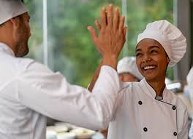
Durability
The food preparation industry requires workers who are physically and mentally healthy and have stamina. The pressure of working in food preparation is high due to challenges in terms of time and customer demands. Being able to work under high pressure is a characteristic of a good food preparation worker.

Cooperate With Colleagues
Some of us work in premises with few employees, some with many. There are situations where we may work alone. Usually, in the preparation of food, we are required to work with others in completing tasks. Helping each other and being able to cooperate is the key to being a great team. Working in the food preparation industry is working in a team.

Desire To Learn
Culinary knowledge is extensive and is lifelong learning. Great chefs are always humble and willing to learn new cuisines. Working and adding life experience is a learning process. Similarly, attending formal classes and diligently reading can increase the knowledge of a cook.

Produce Quality Food
All cooks need to instill the determination that every food produced must be of good quality and meet the needs of the customer. Despite only serving food at roadside stalls, the commis chefs prepare the food as stated in the menu and meet its standards. Quality and tasty food can indirectly increase customers.

(C01/1-2)
PARTS AND FUNCTIONS IN KITCHEN ORGANIZATION MANAGEMENT

(C01/1-2-1)
KITCHEN ORGANIZATION AND ITS FUNCTIONS
A glance at the history of food preparation
There is no exact date as to how this food handling began. Humans have been involved in the practice of food preparation since time immemorial. Until the French Revolution in 1979, the term Modern Food Service appeared. Before this era, Cooks or Chefs were more focused on serving in the homes of the aristocracy.

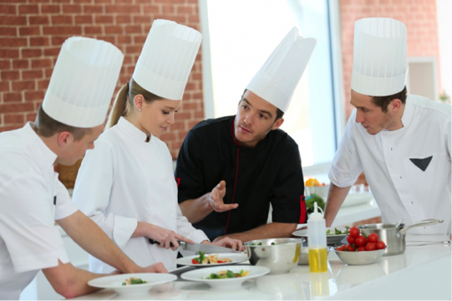
Some notable figures in Modern Food Preparation:
- Carême (1784-1833)
Responsible for writing a book that systematically explains cooking techniques, recipes and making menus.

- Esscoffier (1847 – 1935)
Known as "The Chef of Kings and The King of Chefs,"
His two main contributions
- simplify and simplify the traditional recipe
- revamping and arranging kitchen organization towards Modern Kitchen Organization

Classic and Modern Cuisine
According to the western view, there is the biggest difference between classical and modern cuisine in terms of calorie intake and portion size. The classic cuisine based on 2 things namely butter and cream, where food is served for 6-10 courses and sometimes up to 20 courses at a certain event and it is no longer suitable nowadays. Classical cuisine cannot be mixed between Europe and Asia.

While modern cuisine is a combination of food and preparation style between several countries such as France, Europe, the United States and Canada and the influence of Asian cuisine. For example, the chef combines Japanese cooking techniques with Asian influences on a French-based dish known as "Fusion".

Modernization And Impact On Kitchen Operations
We cannot run away from facing the current of modernization. The food preparation industry is also embracing modernization. Although traditional cooking techniques are still used in menu planning at this time, the rapid development in terms of technology, modern food preparation equipment, new food products, lifestyle and awareness of food nutrition are changing food preparation patterns. Indirectly, today's food entrepreneurs are also changing to modern kitchen operations that are more economical in operating costs, relaxed, food presentations that are more attractive and popular among young people.

Terms such as Fusion Cuisine, Sous Vide and Molecular Gastronomy are beginning to attract the interest of today's chefs to develop their talents and markets to compete in the globalized world. In addition, globalization or a world without borders also has an impact on the way people eat in this country such as increasing demand to Korean Food along with the spread of KPOP music.
Modern Kitchen Organization
The purpose of the modern kitchen organization is to define specific tasks according to the type of menu and assign the responsibilities of the cook based on the hierarchy found in the kitchen organization. The size of the organization depends on the size of the place and the amount of kitchen and equipment available in the organization.

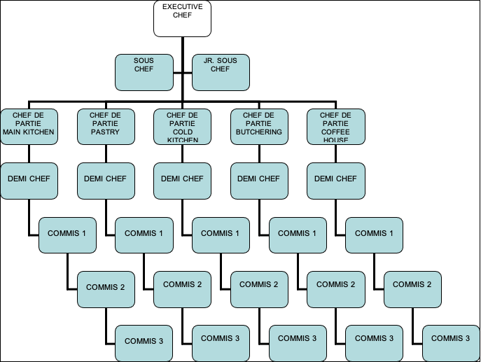
Basics of Kitchen Organization Formation
The purpose of the organization of a kitchen depends on several criteria as follows:

Menu Type
The number of chefs required in a premise depends on the menu. Employers will certainly look for employees who are good at preparing a planned menu. Therefore, in planning a food business, planning a menu is very important because the menu is a factor that contributes to the selection of employees, equipment and also the cost of business operations.
Size of Business Operation
Premises Equipment and Facilities

CLASSIC KITCHEN  Type of Premises  Owners of service operations need to determine the type of premises they want to open such as:  - Hotels  - Institutional Kitchen  - School / Boarding School  - Hospitals, welfare centers and health care centers  - Airline Catering  - Military camp / PLKN  - Private club  - Catering and banquet operations  - Fast food restaurants  - Restaurants  - Food providers in supermarkets  Comparison of Classic and Modern Kitchen Organization | MODERN KITCHEN
EXECUTIVE CHEF (Chef de cuisine)  Responsible for the overall management of the kitchen, supervising staff, creating new menus and recipes with the help of the restaurant manager. | EXECUTIVE CHEF/ CHEF de CUISINE  - Responsible for the kitchen  - Operations.  - Menu planning and quality control  - product made.  - Manages employees under his management.  - Controlling the purchase of ingredients (food purchasing), menu control (menu costing).  - Supervise the work schedule of employees under his supervision.  - Planning and managing the purchase of kitchen equipment as needed.  - Provide courses for subordinates.  - Control the cost of purchasing materials.  - Prepare special dishes according to request.
ASSISTANT CHIEF COOK  (Sous-chef de cuisine)  - Responsible for preparing the kitchen staff schedule or replacing the chef when the chef is on vacation and assisting the Chef de Partie if needed.  - Responsible for cleanliness, organization and ongoing training for all kitchen staff. | SOUS CHEF  - Assisting the executive chef in controlling kitchen operations.  - Help the chef plan the menu and control the quality of the food.  - Controlling the portions of food prepared to follow the standards and specifications set.  - Control the use of materials by each outlet.  - Assist the chef in ordering ingredients.  - Do food testing for a new menu dish.

CLASSIC KITCHEN | MODERN KITCHEN
SAUCE COOK (Saucier)
A position in the classic kitchen that time is used in commercial kitchens such as some restaurants. His job is to prepare sauces, stews and sautés.
SENIOR ASSISTANT (Chef de Partie)  As the leader who manages the stations in the kitchen and specializes in preparing certain dishes. | CHEF DE PARTIE  - Controlling the quality and standards of food set.  - Prepare work schedules for staff under his supervision.  - Control the cost of materials used.  - Making material orders for responsible outlets.  - Ensure subordinate staff always comply with hotel policy.  - Ensuring his subordinate staff always maintain cleanliness and safety at the station.  - Prepare meals for certain occasions.
COOK (Cuisinier)  Responsible for preparing certain dishes in the station (section) in the kitchen. | DEMI CHEF  - Assist the chef in ordering ingredients.  - Help the chef make a work schedule.  - Give instructions to new staff to prepare a meal.  - Helping the chef control the quality and quantity of food prepared.  - Prepare meals according to the outlet.  - Ensuring his subordinate staff always maintain cleanliness and safety at the station.
COMMIS  A new cook, responsible for cooking and working under the chef de partie. | COMMIS  - Appointments for Commis 1, 2 and 3 depend on the work experience and academic level of a staff member.  - Prepare meals for each outlet that is responsible.  - Always comply with hotel policy.
APPRENTICE  Doing preparatory work or cleaning work to increase theoretical and practical training and increase working experience in the kitchen. | None
ROTISSEUR  Cooks who prepare roasts, broils and fries | None
GRILLARDIN  A cook who prepares grilled dishes but is not a Rotisseur. | None
FRITURIER  Cooks who prepare fried food | None

CLASSIC KITCHEN | MODERN KITCHEN
POISSONNIER  Cooks who prepare fish and seafood dishes. | None
ENTREMETIER  Prepare soups and other dishes that do not involve meat or fish, including vegetable and egg dishes. | None
POTAGER  Prepare the soup found in the menu. | None
LEGUMIERS  Prepare a vegetable dish. | None
GARDE MANGER  Prepare cold dishes (such as salads, appetizers, canapes, pates and terrines) and create decorative elements of the buffet presentation such as ice sculptures and centerpieces made from ingredients such as cheese, fruits and vegetables, butter, dough or fat. | None
TOURNANT  Move around the kitchen helping all positions in the kitchen. | None
PASTRY CHEF  Proficient in making pastries, desserts, bread and other baked dishes. | None
CONFISEUR  Confiseur in larger restaurants, preparing sweets. | None
GLACIER  In larger restaurants, serve frozen and cold desserts instead of pâtissier. | None
DECORATEUR  In larger restaurants, prepare and display fruit and specialty cakes instead of the pâtissier. | None
BOULANGER  In larger restaurants, serve bread, cake, and breakfast pastries instead of pâtissier. | None
ABOYEUR  Take orders from the dining room and distribute to various stations; can also be performed by the sous-chef de partie. | None
COMMUNARDS  Prepare food served to restaurant staff. | None
GARCON  In larger restaurants, perform preparatory and additional work for support. | None

(C01/1-2-2)
KITCHEN OUTLET FUNCTION
Within a hotel organization, there are several main kitchen outlets. This outlet also depends on the size and star level of each hotel. This outlet has its own role where this outlet will provide different product results.

Main Kitchen/Banquet
- The size of the kitchen and equipment is larger to accommodate more portions.
- Has several sections under it, such as Malay Kitchen, Chinese Kitchen, Western Kitchen.
- Prepare meals for specific functions based on event order (E.O), in addition to providing buffet lunches for the coffee house every day.

Coffee House
- The size of the kitchen and equipment is smaller
- Prepare meals based on customer requests or A' La Carte or Table d'hote.
- Also involved in the preparation of A' La Carte ordered through the room service department, where the meal will be delivered to the room of the customer who made the order. It usually operates 24 hours but usually depends on the type of hotel.

Cold Kitchen / Garde Manger
- Smaller kitchen size and often has a special room with a certain temperature
- Prepare cold food dishes such as salad-based appetizers, entrees, dressings, patties, terrines and so on
- In smaller operations that offer simpler meals, the cold kitchen is better known as a salad station or pantry.

Pastry Kitchen
- Having a special room and the equipment depends on the type of product produced
- Prepare dishes based on desserts and bakery products.
- Prepare dessert dishes for buffets and functions
- Certain
- Prepare cakes based on orders made by customers such as wedding cakes, birthdays, anniversaries and others.

Butchery
- Has a special room and is close to the kitchen
- Has storage space such as chiller and freezer
- Perform butchering work such as cutting, deboning and
- trussing.
- Provide needs according to demand from the outlet.

(C01/1-2-3)
SKILLS LEVEL
The word Chef generally means the person who is the head cook. Similarly, the term Chef comes from the French word meaning 'Chief' or 'Head'. The title of Chef is earned based on experience not only in preparing food but also in staff management and in production planning. New cooks who want to advance in the food preparation career need to respect the term Chef.
The skills required for food preparation staff vary not only with the level of employment but also with the type of food prepared. A hospital kitchen director and an Executive Chef at a luxury restaurant require different skills. The skills needed by a cook in a coffee house are not the same as those needed by a cafeteria worker in a school. However, we can break down the skill level of a cook into three general categories.

Supervision (Supervisory)
The Head Chef, called an Executive Chef, Sous Chef, or director of nutrition, must have management and supervisory skills and a thorough knowledge of food production. The leadership position requires an individual who understands the management and motivation of his subordinates, planning menus, food production procedures, controlling costs and managing the kitchen budget, as well as managing the purchase of raw material supplies and equipment.
Although the Executive Chef may not cook at all, the Executive Chef must have extensive experience in food preparation to schedule production, direct employees, and control culinary quality. The Executive Chef, too, must be able to work well with others even under extreme pressure.

Skilled And Technical
The Executive Chef is the leader in the kitchen, while the cook is the backbone of the Chef. The cook is the real food provider. Therefore, they must have knowledge of food and cooking and be experienced in cooking techniques, at least for dishes made in their own kitchens. In addition, they must be able to work well with colleagues, they can also work with other departments. Food preparation is teamwork

New Employee (Entry-Level)
New employees in food service usually do not require specific skills or experience. New employees in this job are usually given jobs such as washing vegetables and preparing green salads. As their knowledge and experience increases, they will be given more complex tasks and eventually become master chefs. Many Executive Chefs began their careers washing and peeling potatoes early in their careers.
Starting at the bottom and moving up the job hierarchy through work experience is the traditional method of advancing a food preparation career. However, today many cooks are college graduates in culinary programs. But with that kind of education, many new graduates start at the entry-level level. This is what it should be and certainly should not be seen as a factor causing graduates not to venture into the food preparation industry.

Programs such as Culinary Arts at the tertiary level teach general cooking knowledge, while each food service field requires specific skills according to its own menu. Experience as well as theoretical knowledge is required to be able to adapt to real work situations. However, a student who has studied and studied well should be able to work well and advance his career faster than a new employee without knowledge.

(C01/1-2-4)
PROFESSIONALISM STANDARD OF A CHEF

Skills
To reach the level of a Chef, skill is the main yardstick in evaluating their abilities. To be a good cook, apart from having skills in cooking, a chef also needs to learn interpersonal skills and management skills.

Experience
There is an expression "A person still does not know how to cook a dish well until he cooks it 1000 times". This expression refers to the experience of cooking is very important. Cooking experience cannot be replaced with a certificate. Knowledge gained from reading or watching from YouTube does not make us great in food preparation. Only practice and experience produce great and quality cooks.
Knowledge
Although experience in cooking is the main element that determines the level of professionalism of a chef, knowledge is also an added value in increasing his level of professionalism. Many government and private colleges offer culinary studies to today's students. Indirectly, chefs nowadays also have high skills and knowledge.

(C01/1-2-5)
CUSTOMER EXPECTATIONS
As is well known, food is a basic human need apart from clothing and shelter. In Maslow's theory of Needs, there are five elements presented which are physiological, safety, social, self-esteem and self-reliance. In this theory, physiology is a fundamental matter. Physiology includes aspects of basic human needs such as food, clothing and shelter. Food is a basic need for humans to continue living in this world. In this theory too, Maslow's said hunger is something that causes people to feel uncomfortable and this problem can only be overcome by food.

Customer expectations are different. For the group aged between 45-54 years, their selection of restaurants is different because this group is more likely to choose restaurants that have food quality, atmosphere factors, prestige, comfort and immediate action taken by the restaurant operator when a complaint is made. For the high and middle income groups, they choose restaurants that have comfort as their main choice. High income groups are also more likely to choose restaurants that have quality, service offered, prestige, comfort, personal and comfort.

In addition, middle and high-income groups prefer "gourmet" restaurants, which means restaurants with perfect dishes. The "gourmet" restaurant is also a high-prestige restaurant, with a high quality of food that is fresh, an effective atmosphere and the friendliness of the staff.
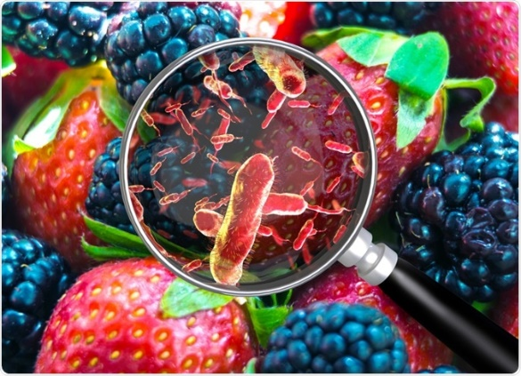
(C01/1-3-0)
MAINTAIN PERSONAL HYGIENE PRACTICES

Food Contamination
Food contamination means the presence of foreign matter in food that makes the food unsafe to eat. Food contamination is caused by microorganisms and chemicals. Contaminated and unclean food can contain harmful substances or germs that can cause foodborne diseases such as cholera, typhoid, poisoning, jaundice (Hepatitis A) and others. Therefore, every individual who handles food must have knowledge about infectious diseases through food, know personal hygiene care and practice sanitation at all levels of handling and selling food. It aims to ensure that the food is safe to eat, not contaminated and can prevent the occurrence of food poisoning.

There are 12 main factors of food contamination which are:
- Do not touch food with your hands
- Cross-contamination between raw materials and ready-to-eat foods
- Cook too early (Serve More Than 4 Hours)
- Food is not cooked enough
- Heating and mixing old food with freshly cooked food
- Raw materials are damaged or contaminated
- The raw material is not completely defrosted
- Storage of raw materials and food at the wrong temperature and place
- Food handlers are sick and do not practice good personal hygiene
- Food is vulnerable to pests
- Dirty and imperfect equipment
- Food handlers do not have typhoid vaccinations
In general, choosing a restaurant depends on the quality of the food and the type of food. Location, prestige, atmosphere and cost of food are critical factors in the selection or rejection process. If all these factors meet the requirements then the restaurant will be selected but if the desired criteria are lacking then the restaurant will be rejected. Looking at the customer's taste, food quality is the main choice in choosing a restaurant. By making the quality of the food the main reason customers visit the restaurant.
CAUSES OF POLLUTION |  | DESCRIPTION
Microorganisms | Bacteria  1. Bacillus  2. Staphylococci  3. Streptococcus  4. Diplococci  5. Spirilla | - Bacteria are single-celled organisms that cannot be seen with the naked eye. Its diameter is approximately 1 cm and has a variety of morphological variations such as short rods, tapers, spheres, and cocci shaped.  - Bacteria bleach unstable food colors through the production of various colored pigments and slime.  - Pigment colors are red, brown, young, orange, blue, green, black, and purple.  - Contaminated meat will change color from red to blackish red.  - Some species of bacteria produce spores that are resistant to heat and chemicals known as thermophilic microorganisms.  - It releases a type of toxin that can cause infectious diseases through food
(C01/1-3-1)
HYGIENE AND SAFETY ASPECTS IN FOOD HANDLING

CAUSES OF FOOD POLLUTION

Microorganisms

Microorganisms are artistic life found in all non-sterile matter and in many forms. They include bacteria, fungi, and yeast. Not all these microorganisms are harmful, in fact some of them are used in food preparation. Microorganisms that can cause food poisoning can multiply rapidly if they are in conducive conditions and are known as pathogenic organisms. The secretion of these microorganisms is known as toxins or poisons that contaminate food.

Chemical substance

Chemicals are solid, liquid or gaseous substances used in food processing. The small amount of chemicals in food does not affect humans. It becomes dangerous when used excessively. Certain chemicals intentionally or unintentionally end up in food through:
- Use of additives in food production.
- Chemicals used in agriculture such as pesticides, chemical fertilizers and animal feed.
- The use of utensils made of metal during the preparation and service of food and beverages

CAUSES OF POLLUTION |  | DESCRIPTION
Microorganisms | Bacteria  1. Bacillus  2. Staphylococci  3. Streptococcus  4. Diplococci  5. Spirilla | - Bacteria are single-celled organisms that cannot be seen with the naked eye. Its diameter is approximately 1 cm and has a variety of morphological variations such as short rods, tapers, spheres, and cocci shaped.  - Bacteria bleach unstable food colors through the production of various colored pigments and slime.  - Pigment colors are red, brown, young, orange, blue, green, black, and purple.  - Contaminated meat will change color from red to blackish red.  - Some species of bacteria produce resistant spores
- The use of utensils made of metal during the preparation and service of food and beverages

CAUSES OF POLLUTION |  | DESCRIPTION
 | Fungus | - Fungus is a multicellular microorganism with a filamentous morphology. Tube-shaped cells with a diameter of 30 to 100ϥm, known as tuft-shaped hyphae called mycelium.  - Fungi are easily recognized through their moldy or fluffy properties such as on bread, jam and cheese.  - Fungi can produce many fine spores that can be spread by the wind.  - Most fungi are harmless to health, but some produce mycotoxins under certain conditions and become toxic to humans.  - Almost all foods can be overgrown by fungi either before harvest or during storage.  - This fungus can be detected when there are rotting, slimy, fluffy spots or colored spores.  - It emits odors due to fermentation changes resulting from enzyme reactions on carbohydrates, fats and proteins in food
 | Yeast | - Yeast is an artificial plant cell. It reproduces through the process of budding.  - Food contamination due to yeast can be identified through foaming and the smell and taste of alcohol in the food.  - Saccharomyces is a harmless type of yeast, while Blastomyces is a pathogenic type.
Chemical substance | Insecticides | - Recommended insecticides for use in the kitchen.  - Extracts of pyrethrum, malathion and indiara for cockroaches.  - Pine oil, cypermethrin and indiara for flies.  - Cypermethrin, malathion and indiara for ants.  - Warfarin and bromadiolone for rats  - Excessive spraying of insecticides such as arsenic by farmers on fruits and vegetables can cause poisoning.

CAUSES OF POLLUTION |  | DESCRIPTION
 | Additives | - Additives are used as preservatives to extend the shelf life of a product.  - The following additives according to the type of food:  - Sorbic acid for soft drinks and fruit yogurts.  - Calcium sorbate for frozen pizza.  - Potassium nitrate for cured meats and this ingredient also gives bacon its pink color.  - Sulfur dioxide for dried fruits such as raisins. This ingredient also acts as a natural color retainer.  - Benzoic acid for dansos soy sauce.  - Boric acid for fish balls and noodles.
Signs And Symptoms Of Food Poisoning

Signs and symptoms of food poisoning depend on:
- The causative agent of the poisoning.
- Amount (dose) of bacteria, virus or toxin.
- A person's age.
- A person's immune system.

Patients with food poisoning may experience:
- Nausea.
- Diarrhea.
- Vomiting.
- Stomachache.
- Sweating/fever.
- Headache.
- Fatigue.

The effects of food poisoning can result in disability such as paralysis, or long-lasting (chronic) joint pain. It can also lead to death if not treated early.

Food Handling Guide
Under the Food Hygiene Regulations 2009, food handlers are required to undergo a health check to identify whether they have infectious diseases or water and food borne diseases that can cause food contamination. Examples of infectious diseases: Hepatitis B, Tuberculosis, Human Immunodeficiency Virus (HIV) and others.

Here are the practices that food handlers need to know.
- Food handlers must have a certified health certificate or card.
- Food handlers are not allowed to handle food if they have diarrhea, fever, and scabies.
- The food handler's injured hand must be wrapped with a waterproof plaster before handling food.
- Food handlers must attend a Food Handling Course that has been recognized by the Malaysian Ministry of Health.
- Food premises and restaurant operators have a responsibility to keep an up-to-date health register of food handlers.

(C01/1-3-2)
Personal Hygiene Practices
Food hygiene starts from the food operator himself. As well as food that looks clean, customers are also more easily attracted by the image of a good food operator, clean equipment used and perfect and clean premises. Characteristics of good food handler clothing:
- Wear decent, clean and appropriate clothing.
- Wearing a brightly colored apron.
- Covering the head with a suitable, clean and easily washable cover.
- Required to wear shoes while handling food.
- It is NOT allowed to use slippers and the like.
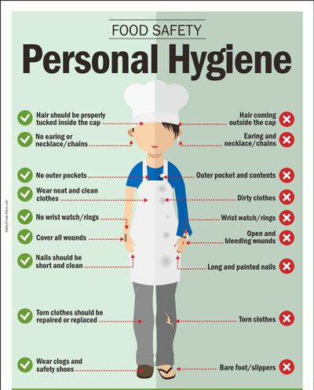
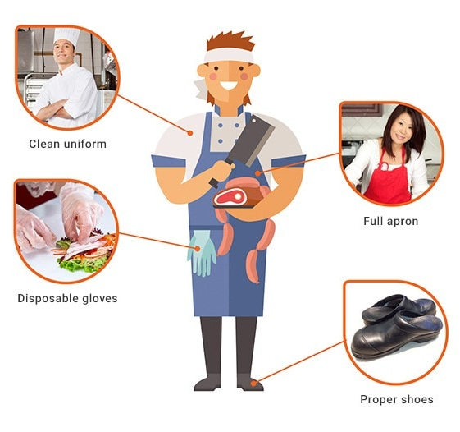
Good Food Handler Practice
Food handlers shall
- Always have short nails.
- Wash your hands after going to the toilet before handling food.
- Smoking is not allowed while handling food.
- Do not blow your nose while handling food.
- Never cough or sneeze into food.
- Maintain personal hygiene while handling food.
- Use a clean, separate cloth to wipe dishes, sweat and dirt.
- Clean forks, spoons, knives and cups must be held by the handle.
- Cooked food can only be handled with spoons, forks and chopsticks.
- It is forbidden to spit everywhere.
- Signs such as 'Don't spit anywhere', 'Pets are not allowed in food premises' and business licenses should be provided and placed in a suitable and easily visible place.
Clothing
Clothing etiquette that food handlers should not practice during food handling:
• Not wearing a hair cover
• Wearing a dirty apron
• Wear slippers
• Using a dirty wiping cloth
• Smoking
• Wearing jewelry or accessories
• Handle food if you are not healthy (Flu, fever, cough, etc.)
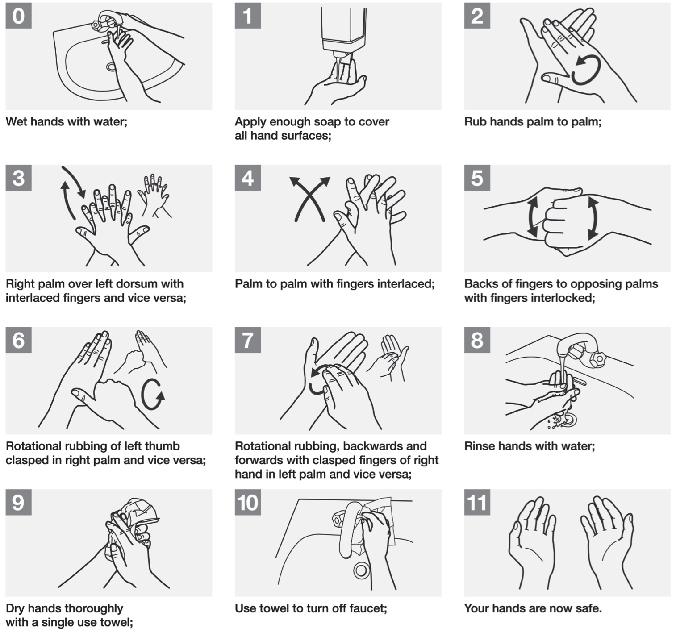
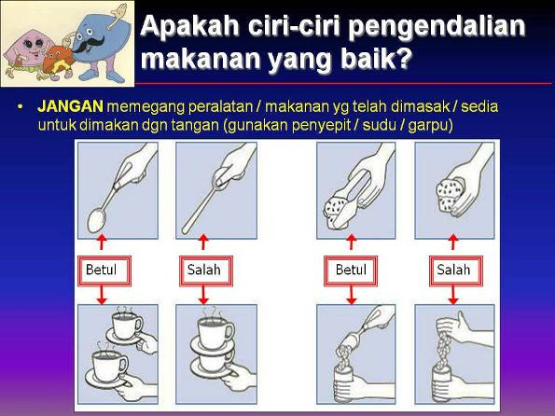
Food Handler Best Practices
One of the effective systems in handling food safely is practicing the Hazard Analysis Critical Control Point (HACCP) System. This system is widely applied by food operators around the world. The purpose of the HACCP system is to identify, monitor and control food contamination hazards.

There are 7 steps to the implementation of the HACCP System:
- Assess Hazards
- Identify Critical Control Points (CCPs)
- Set up standards or limits for CCPs
- Set up procedures for monitoring
- Establish corrective actions
- Set up a recordkeeping system
- Verify the system is working

(C01/1-3-3)
SAFETY MEASURES IN THE WORKPLACE

Avoiding Wound Injury
- Keep the knife sharp. A sharp knife is safer than a dull knife.
- Use a cutting board. Avoid cutting food on a metal worktop. Place a damp cloth under the cutting board to prevent the cutting board from sliding.
- Pay attention when handling cutting equipment. The knife is placed on the worktable. Do not carry a knife when taking ingredients or chatting with friends.
- Do not put sharp objects such as knives in the sink with water.
- Do not catch a falling knife
- Store knives or sharp tools in a safe place such as on a knife rack.

Avoiding Burn Injuries
- Get used to thinking that the pot / pan in the kitchen is hot. Avoid holding pots/pans with your bare hands, get used to having a cloth pad when you want to hold pots/pans in the kitchen.
- Use a dry cloth when handling hot equipment. Damp or wet cloths can generate hot steam
- When cooking, turn the pot/pan handle towards the wall. Do not point the pot / pan handle towards the path or the cook.
- When handling tools that produce hot steam, avoid opening the lid directly.
- Wear long-sleeved shirts when in the kitchen.
- When frying, avoid fried foods that contain a lot of water, because water causes oil to splatter.
Avoiding Fire Or Facing A Fire Situation
- Know the position of fire extinguishers in the work area
- Use the correct fire extinguisher according to the type of fire source
- Do not use class A extinguishers on grease, oil or electrical fires as they will fuel the fire.
- Make sure not to heat the oil for too long.. Can cause a very hot fire.
- Do not smoke in the kitchen
- Check fire extinguishers as scheduled.
- Make sure the emergency passage area is not obstructed

Avoiding Injuries When Using Machines And Equipment
- Learn first how to use the equipment before use
- Make sure the safety rules of use are still followed
- Close the machine plug after use.
- Avoid handling electrical sources with wet hands
- Wear appropriate clothing when operating equipment
- Do not misuse tool functions

Avoid Falling
- If there is a liquid spill on the floor, clean it up immediately
- Sprinkle salt on the oil or liquid spill while waiting for the spill area to be cleaned up
- Do not lift heavy or large objects alone
- Walk, don't run in the kitchen
- Use appropriate shoes in the kitchen
- When climbing to pick up materials on high shelves, use a ladder

Avoiding Accidents When Lifting Heavy Equipment
- Lift using proper technique
- Do not twist your body when lifting heavy materials
- Use a trolley to carry heavy materials
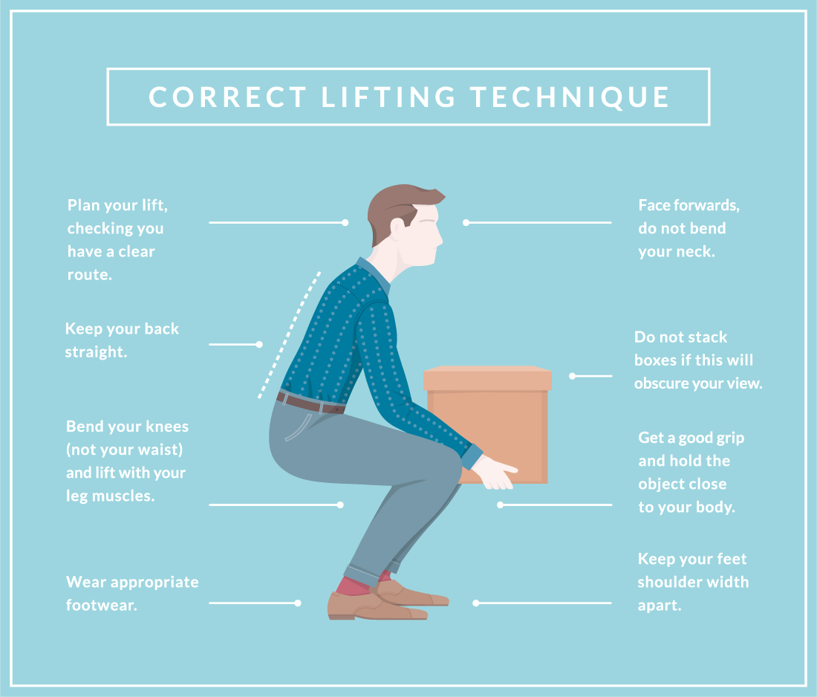
QUESTION:

1. List the duties of an Executive Chef?

__________________________________________________________________________________________________________________________________________________________________________________________________________________________________________________________

2. State the function of the Garde Manger kitchen?
__________________________________________________________________________________________________________________________________________________________________________________________________________________________________________________________

[Title]
Apply Kitchen Workstation Safety

This information paper aims to provide understanding and knowledge to trainees about equipment, hardware and hand tools in food preparation.

JABATAN PEMBANGUNAN KEMAHIRAN
KEMENTERIAN SUMBER MANUSIA
ARAS 7 & 8 BLOK D4, KOMPLEKS D
PUSAT PENTADBIRAN KERAJAAN PERSEKUTUAN
62502 PUTRAJAYA

EXPLANATORY PAPER

PROGRAM CODE AND NAME | I56-005-2:2022 FOOD PREPARATION AND PRODUCTION
LEVEL | L2
NO. AND UNIT TITLE OF COMPETENCY | C01: Practice kitchen hygiene and safety procedure.
NO. AND WORK ACTIVITY STATEMENT | - CARRY OUT KITCHEN PERSONAL HYGIENE  - APPLY KITCHEN WORKSTATION SAFETY  - APPLY KITCHEN FOOD SAFETY PROCEDURES
NO. CODE | I561-005-2:2022 - C01/P(2/3) | PAGE: 26 - 63

(C01/2-0)
APPLY KITCHEN WORKSTATION SAFETY

(C01/2-1)
INTRODUCTION ABOUT EQUIPMENT IN FOOD HANDLING
Kitchen appliances are very expensive. The hardware used must meet the needs of an organization in addition to being able to save time and energy. The design of the tools, the type of construction made should also be taken into account so that the equipment is easily damaged and needs to be replaced.

Surfaces of equipment and utensils for food preparation, cooking and service should be impervious to water and easy to clean. Hardware should be made of non-toxic, corrosion-resistant, smooth and non-cracked materials.

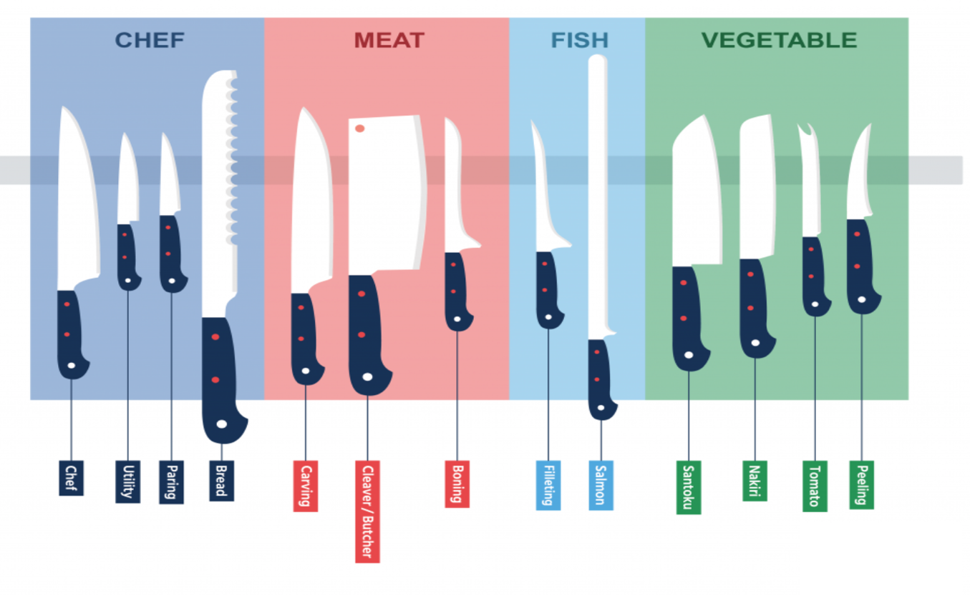
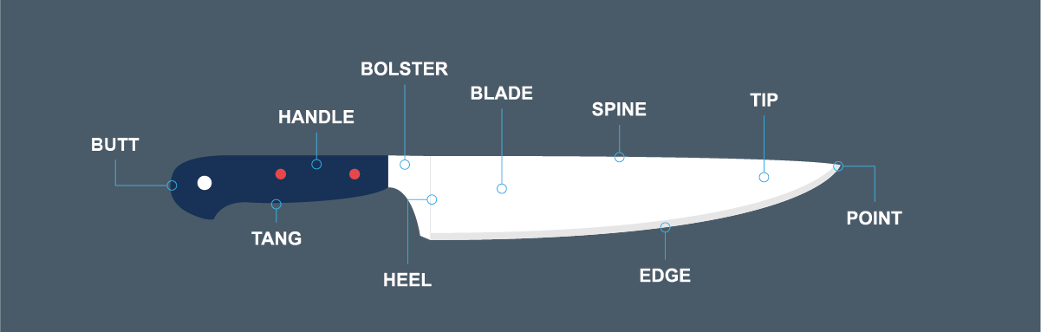
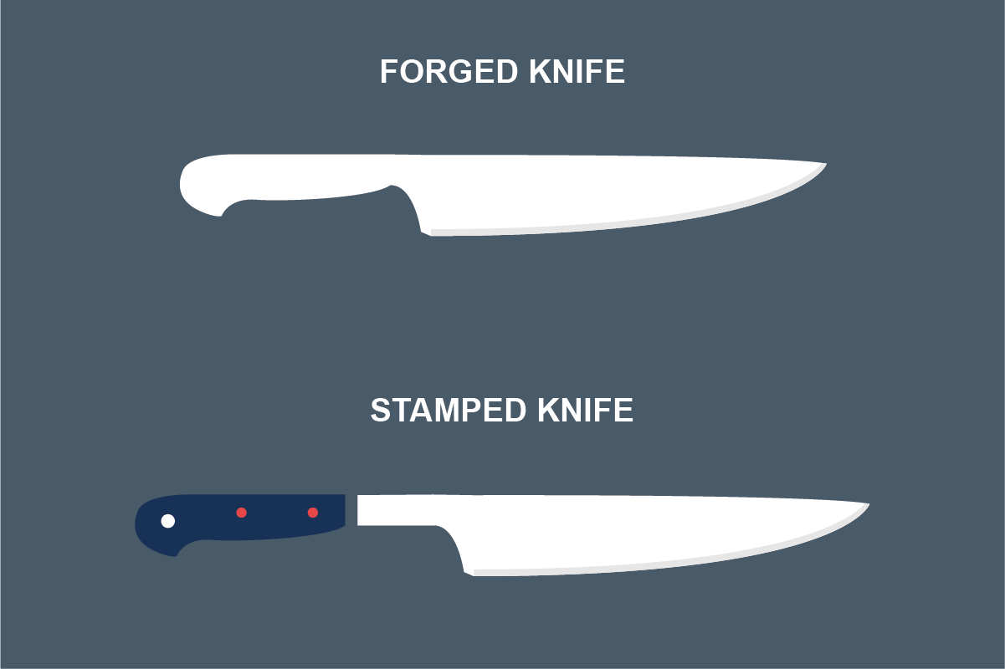
(C01/2-1-1)
KNIFES
Preparing food is easier, faster, and safer when you have the right tools, but with so many different types of knives on the market, finding the one that suits your needs can be tricky. Without the right knowledge, it’s all too easy to buy a selection of specialist knives you hardly ever use — meaning you end up with a selection of unused knives languishing at the back of your utensil drawer.
To complicate matters even further, naming conventions for knives can be seriously confusing, with many cutting tools having multiple names for the same style. To help you make sense of it all, we’ve compiled a guide to every type of knife and their uses, including advice on which one is best for different kitchen tasks. So, whether you’re starting in catering and want to know which knives to invest in, or simply want to kit out your kitchen at home,

The different parts of a knife: Anatomy of a kitchen knife
If you want to find the best-quality knife for a particular task, it will help to have a basic working knowledge of the different parts of a knife. Here, we’ll explain what each part of a knife is called, and what function it serves. You should note that this is just an overview of the different features you will see on most basic knives: many specialist knives may be constructed slightly differently.

Point
The very end of the blade. This is usually sharpened to a fine point, and can be used to pierce or score the surface of food.

Blade
The blade is the name given to the part of the knife which is used for cutting. It’s usually crafted from steel, although it may also be ceramic, titanium or even plastic.
Edge
This refers to the sharpened part of the blade, which is used for the majority of cutting work. The sharpness of the knife is dictated by how finely the edge is ground, and this will depend on both the quality of the knife and how often you sharpen it. It may be serrated (as with bread knives) or it may be straight.
Tip
The front part of the knife’s edge, just beneath the point, is called the tip. It’s the part of the blade which is normally used for delicate chopping and cutting work.
Spine
The spine is the blunt upper side of the blade, opposite to the cutting edge. The thickness of the spine gives strength to blade: as a rule, the thicker the spine, the stronger the blade. It’s also important for providing balance to the overall knife.
Heel
The heel is the lower edge of the blade, furthest from the tip, next to the bolster. It’s often the widest part of the blade. This part of the edge is most commonly used when the chef needs more strength or pressure to cut through thicker or tougher foods.
Tang
The tang is the unsharpened part of the blade which connects the blade edge to the handle. The tang is vital to the overall balance, weight, stability, and strength of the knife. The best knives are often considered to be those with a ‘full-tang’: one which runs from the end of the blade all the way to the butt. In some designs, the tang also functions as a handle.

Handle or scales
Sometimes called ‘scales’, the handle is the part of the knife grasped by the chef during use. It can be made from a number of materials, and may be straight or designed with finger grooves and other ergonomic features that make it easier to hold. Some knife manufacturers will dispense of the handle altogether, instead creating a knife using a single piece of steel, so that the tang also functions as a handle.
Bolster
The bolster is the raised area between the blade and the handle. It puts a small space between the chef’s hand and the blade, to stop the fingers from slipping down onto the blade during cutting work. It also provides additional weight to help balance the knife.
Handle fasteners, or rivets
These are the rivets or screws which fix the handle parts to the tang. Less expensive designs may forego the rivets and attach the handle to the tang using resin or epoxy instead.
Butt
The name given to the end of the handle, at the very bottom of the knife.

Forged vs. Stamped Knifes
Before we talk about the different types of knives in more depth, it will help to outline the differences between forged and stamped knives. These terms refer to the way the knife is made, and there are benefits and disadvantages to each method.

Forged knives
A forged knife is any kind of knife which has been forged from a single piece of metal. To construct a forged knife, a block of steel is hammered into shape using a powerful press, before being honed and sharpened. The handle is then added, before the blade undergoes a final shine and polish.
When steel is forged, the shape is altered right down to a molecular level, meaning the blade is exceptionally strong. In a forged knife, both the blade and the tang are made from one continuous piece of steel, making them strong, durable and well-balanced. Our Tramontina, Wusthof Trident and Sabatier knives are used by professional chefs and cooks around the world for exactly this reason. However, they’re often more expensive than stamped designs, owing to the costly time- and labour-intensive crafting process. But, the upside of this is that you won’t need to buy new knives for many years, as they’re very long-lasting.
You can tell if a knife is forged by looking for a steel bolster between the blade and the handle: this is usually a strong indication that a knife has been forged rather than stamped.

Stamped knives
Stamped knives are made using a single sheet of steel, which is then cut out into the shape of a blade using a powerful stamping machine — a bit like a cookie cutter. The handle is then added, and the knife undergoes hardening, sharpening and polishing to create a keen edge and a smooth finish.

Because they’re constructed from a thinner piece of steel, this type of knife tends to be much lighter than forged knives. The manufacturing process is also much cheaper and quicker, meaning that stamped knives are generally much more affordable than forged ones. However, as a result of this, they’re generally not as good at retaining an edge as forged styles, meaning they will usually need sharpening more often. There’s also a greater risk of the handle breaking.
Stamped knives used to have something of a poor reputation, but nowadays the manufacturing process has been refined and improved, meaning that there are now many brands producing stamped knives of a comparable quality to forged styles. In fact, some cooks even prefer them for their lighter weight and comfortable hand-feel. Manufacturers such as Victorinox and Geisser are renowned for crafting innovative stamped knives of an extremely high quality, so you can get a lightweight stamped knife with a similar sharpness and lifespan to a forged one.
It’s normally possible to tell if a knife has been stamped by looking for a bolster. Stamped knives will not usually have a steel bolster: instead, the heel of the knife runs straight into the handle.

Type of Knife | Description
French Knife / Chef’s Knife  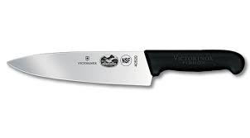 | - French knife or chef's knife.  - The most used knife is a knife in the kitchen, for general chopping, slicing, and dicing.  - The blade of the knife is wide.  - Blade lengths of 8 to 12 inches are the most popular for general work.  - Larger blades are for heavy chopping.  - Smaller blades are for finer work.
Utility Knife  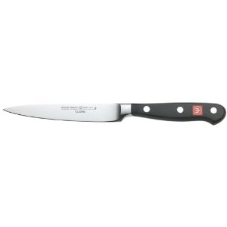 | - A lighter version of the Chef's knife  - Narrow knife blade 5 to 8 inches long, mostly used for pantry work, cutting and preparing salads, fruits and so on.  - Blade lengths of 10-12 inches are the most popular for general work.  - • Larger blades are for heavy chopping. Smaller blades are for finer work.
Paring Knife  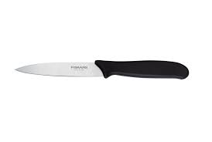 | - Small sharp blades 2 to 4 inches long.  - Used for trimming and peeling vegetables and fruits.

Type of Knife | Description
French Knife / Chef’s Knife  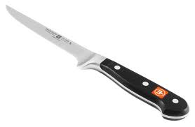  Filleting Knife  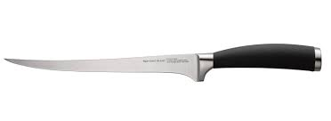 | - Used to separate raw meat from bones.  - One way the knife is used to cut fish filets and has a flexible blade.  - The blade for both boning and the way the knife is thinner and shorter than a chef's knife, about 6 inches long.
Slicer  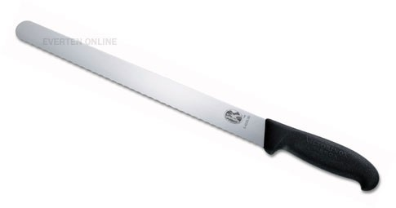 | - Has a long, thin and flexible blade up to 14 inches.  - Used to cut and slice cooked meat.
Cleaver  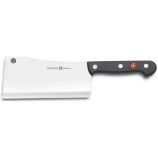 | - Very heavy, broad, and large blade.  - Used to cut through bone.  - Asians use cleavers to peel, cut, chop, and mince.  - Machete that varies in size according to its use.
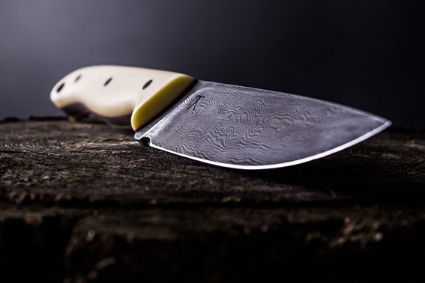
There are more different kind of knife such as
- Bread Knife
- Santoku Knife
- Nakiri Knife
- Tomato Knife
- Peeling Knife
- ETC

What’s the best knife blade material?
The material that your kitchen knives are crafted from can have a big impact on their strength, durability and sharpness, so it can help to know more about the best knife blade materials before you buy.
Each type has its benefits and drawbacks, and some materials are better suited to certain tasks than others. Read on to learn everything you need to know about knife materials before you invest in a new set of knives.

Stainless steel blades
Stainless steel is arguably the most popular material for knives, as it offers great durability and resistance to rust and corrosion. The alloy is made using carbon and iron as a base, and chromium is added to repel stains and give the blade a lasting shiny finish. This makes the blades strong, durable, and very good at resisting staining.
The downside of stainless steel is that there are currently a wide variety of alloys commercially available, so the quality of the steel can vary drastically depending on the supplier. We only stock kitchen knives from professional quality manufacturers, such as Tramontina and Scandi, so you can be sure that any stainless steel knives you buy with us are made using premium alloys.

Carbon steel blades
Carbon steel is a type of steel alloy made from carbon and iron, without the chromium that is added to stainless alloys to help them repel stains. Steel with a high carbon count is often used to forge knives that require exceptional strength and rigidity, and it can also retain an extremely sharp edge when properly cared for. This makes carbon steel a great choice for peeling knives or cleavers.

However, because they don’t have the chromium that’s added to stainless steel alloys, carbon steel blades are prone to staining and discolouration, particularly when they come into contact with acidic foods. So, if you’re after a lastingly shiny collection of knives that you can put on display, it may not be the choice for you. But, if all that matters to you is the sharpness and durability of the edge, you’ll struggle find to a sharper knife than one with a carbon steel blade.

Ceramic blades
A ceramic blade is one that is crafted using hardened zirconium dioxide. They are non-metallic and non-magnetic, and sometimes coated in other materials for extra durability. They’re very lightweight, which many chefs prefer, and they’re also thought to be more hygienic than metal styles. Another bonus of ceramic is that the blades can be printed with stylish patterns, colours or detailing, like our Zenith ceramic knives, which makes them all the more impressive to have on display.
The biggest downside of ceramic knives is their fragility: they’re more prone to breaking or cracking if dropped compare to other types of knives, so they need to be handled with care. They also need sharpening with specialist tools, as regular whetstones will damage the blades. But, with the proper attention, they should be an effective cutting tool for years to come.

Damascus steel blades
Damascus steel is made using two or more different alloys, hammered together to forge a strong steel with an intricate, wavy pattern. Originally invented in medieval Damascus, this type of steel has a long and storied history, and has been used to create knives, swords and other weapons for hundreds of years. This sort of metal is extremely strong, durable and sharp, but nowadays it’s mostly valued for its beautiful appearance.
Modern designs can be expensive owing to the meticulous crafting process, but Damascus steel knives last for years and will retain their sharp cutting edges for a long time. As such, they make excellent knives for serious cooks, or simply items of beauty for collectors.

Ω
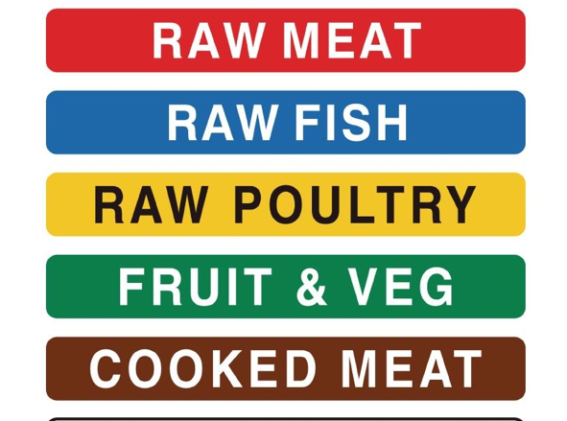
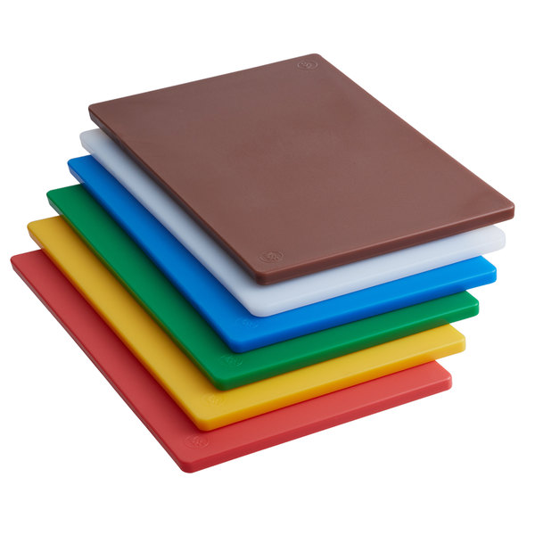
CUTTING BOARD
For safety purposes, a stable work surface avoids damage to the knife and work surface, always use a cutting board. A wooden cutting board should not have holes. Always cleaned should be completely dried before storage. Cutting boards are also made of materials such as PE (polyethylene) or HDPE (high-density polyethylene plastic) and in various thicknesses and sizes. They can be colour coded to avoid cross contamination.

CUTTING BOARD COLOR CODE
- White
A white cutting board is used to cut dairy products and bakery products such as bread.
- Red colour
Cutting board is red, for meat that is red or raw meat that is red, such as beef.
- Yellow colour
For the yellow cutting board in the allocation of poultry such as chicken and duck.
- Blue colour
Blue cutting board for cutting all kinds of seafood.
- Green
Green cutting board for vegetables and fruits.
- Brown
Brown cutting board, for cutting cooked meat.

Titanium blades
One of the hardest materials on the planet, titanium is non-magnetic and highly resistant to rust, which makes it an excellent option for pocket blades and diving knives. But, it tends to be less sharp and not as good at holding an edge, so it’s less effective as a kitchen knife than steel or ceramic types. Nonetheless, many collectors will still prize finely made titanium knives for their stylish dark grey colouring.

Type of Tools | Description
Kitchen Fork  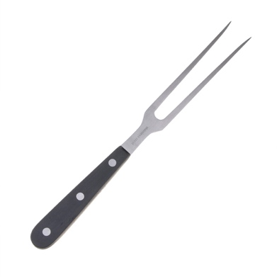 | - Has two or more prongs with pointed ends that can stab food.  - The pointed end may be straight or curved.  - Used to test the degree of doneness of stir-fried meat and vegetables.  - Used to lift ingredients that are ready to be cooked on a cutting board.
Peelers  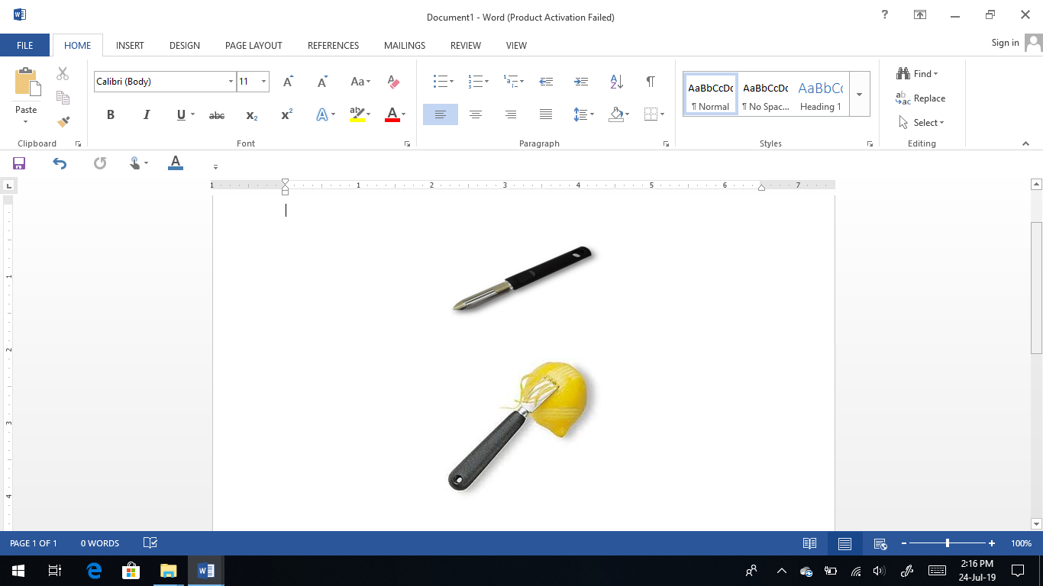  Zester | - Can peel a thin layer from various vegetables and fruits more easily than paring knife.  - The rotating blade can move easily on every material such as vegetables and fruits.  - f the knife blade is sharp on both sides, it peels the skin in both an upward and downward motion.  - The zester is specially designed to remove thin strips from citrus fruits such as lemons, oranges.
Melon Baller  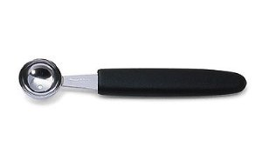 | - Has a small bowl-shaped tip with a small hole (necessary to allow food to escape from the spoon).  - It is designed to scoop out balls or ovals from vegetables and fruits.
(C01/2-1-2)
Other Type of tools
Type of Tools | Description
Spatula  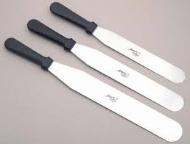 | - Palette knife (metal spatula) is a flexible, round tool mentioned in the kitchen and cake shop.  - Used for icing cakes, flipping grilled food or pancakes.
Rubber Spatula/Scrapper  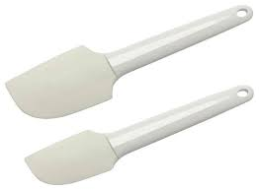 | - Used to scrape food stuck to the sides of the mixing bowl and spread the cream/butter on the bread.  - Also used to whip meringue or cream.  - A stainless-steel scraper is used to cut the dough.
Whisks  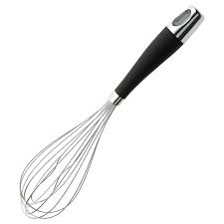 | - Has a small bowl-shaped tip with a small hole (necessary to allow food to escape from the spoon).  - It is designed to scoop out balls or ovals from vegetables and fruits.
Rolling Pin  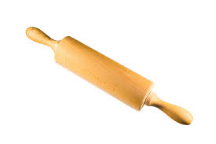 | - Made of hard wood.  - Use a dry cloth to wipe clean immediately after use.  - Do not soak in water.

Type of Tools | Description
Grater  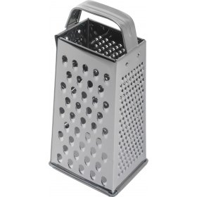 | - A four-sided metal box with grids of different sizes.  - Used to shred and grate vegetables, cheese, citrus fruits and other foods.
Chinois  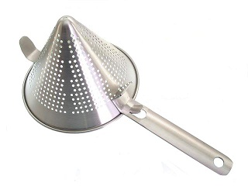 | - Used to strain liquids to obtain a smoother texture.
Strainer  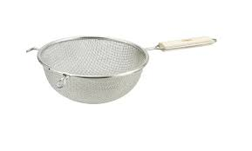 | - Used to filter / strain pasta, vegetables, and others
Colander  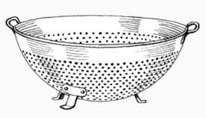 | - A large perforated bowl used for straining/draining vegetables, pasta, salad and other food items.
Sieve  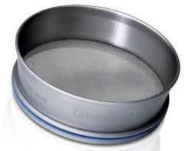 | - Used to sift flour and other dry ingredients.

Type of Tools | Description
Pastry Brush  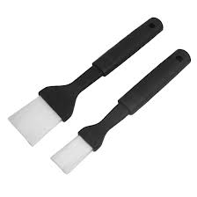 | - Used to brush eggs on foods such as biscuits, bread before baking.  - Also used to grease baking trays, cookie molds and cakes.
Pipping bags and Nozzles  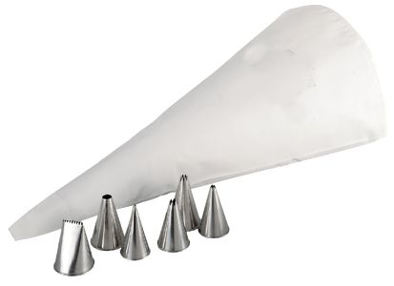 | - Cone-shaped icing bags that are used with nozzles of various sizes and patterns.  - Used to shape or decorate cakes, duchesse, and soft dough.
(C01/2-1-3)
POTS, PAN, AND CONTAINERS

Stock Pots
A large, deep, heavy pot for stocking and bubbling large quantities of liquid. Stock pots with spigots allow liquid to drain without disturbing solid contents or lifting the pot. Sizes: 8-200 quarts (or litres).

Sauce Pots
A half-depth round pot. Same as stock pot but shallower, to make it easier to stir or mix ingredients. Used for soups, sauces, and other liquids. Sizes 6-60 quarts (or litres).

Brazier
Round, wide, shallow, and heavy-duty pots. Used for browning, boiling, and braising meat. Sizes: 11 to 30 quarts (or litres).
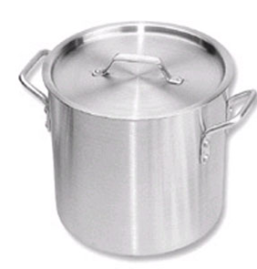
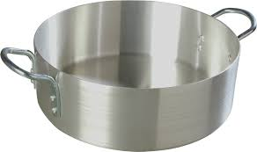
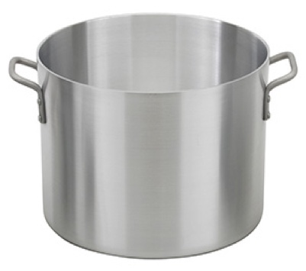
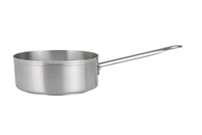
Saucepan
A pot like a small, shallow, shiny pot, but with one long handle instead of two looped handles. May have straight or slanted sides. used for a variety of general cooking. Size: 1 1/2 to 15 quarts (or liters)

Sauté Pan. Straight sided
Just like a saucepan but straight and heavier. Used for browning, braising, and frying. Due to the large surface area, the pan is used to cook sauces and other liquids when a quick reduction process is required. Size: 2 1/2 to 5 inches (65 to 130mm) in 6 to 16 inches (160-400 mm) diameter.

Sauté Pan, Slope-sided
Also called a frying pan. Generally, used to cook and fry meat, fish, vegetables, and eggs. The slanted sides allow the cook to flip and toss the cooked ingredients without using a spatula, making it easier to get the food fried when the spatula is used. Size: 6 to 14 inches (160-360 mm) top diameter.

Double-Boiler
The bottom of the pot is the same as a stock pot, which serves as a place for boiling water. The upper part to place food so that the food is cooked at a low temperature and not directly exposed to heat. The concept of use is like a steamer pot. Size for the upper part: 4 to 36 quarts (or liters).

Baking Tray
Rectangular trays (1 inch / 25mm deep) are used to bake cakes, bread and biscuits and to bake or heat certain meats and fish. Size: Full tray, 18 x 26 inches (46x66cm); half tray 18x13 inches (46x33cm).

Roasting Pan
Rectangular trays are larger, deeper, and heavier than baking trays. Used to grill meat and chicken.
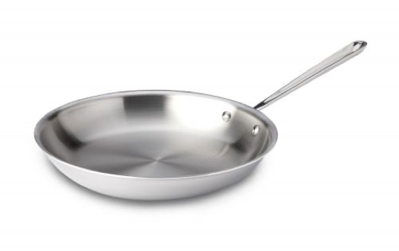
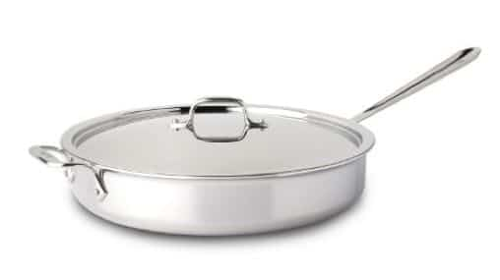
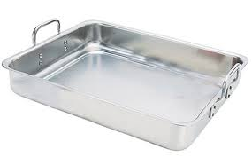
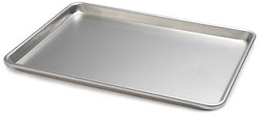
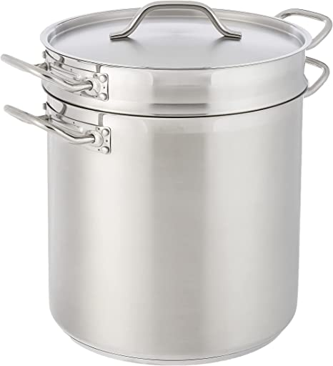
Type of Measuring Tools | Description
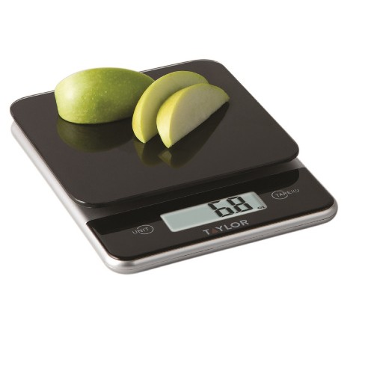  Measuring Scale | Most ingredients in recipes are measured by weight, so accurate weighing is very important. Part of the scale is used to measure materials and also to divide products for services.
Measuring Jug  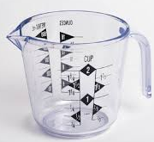 | Used to measure liquids such as milk, oil, water and others. The jug has a lip/spout to facilitate the process of pouring the measured liquid.
Measuring Spoon  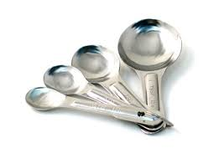 | Used to measure liquid or solid ingredients in small amounts for a recipe. Ingredients such as sugar, salt, oil, milk and others. Each spoon has a different size
Termometer  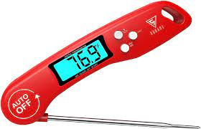  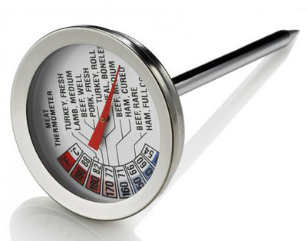 | A thermometer is for measuring temperature. There are several types for various purposes.  - A meat thermometer shows the internal temperature of the meat. It is added before cooking and left in the meat during cooking.  - Instant-read Thermometer gives an instant reading when inserted into food. Reads from 0̊ F to 220̊ F. Chefs usually carry it in their shirt pockets due to its small size  - iii. Fat Thermometers and Candy Thermometers for testing hot oil and heated sugar. Can read up to 400̊ F heat

Type of Measuring Tools | Description
Ice Cream Scoop  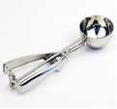 | Used to portion something soft like Ice Cream and Cookie Dough. A round scoop is more practical.
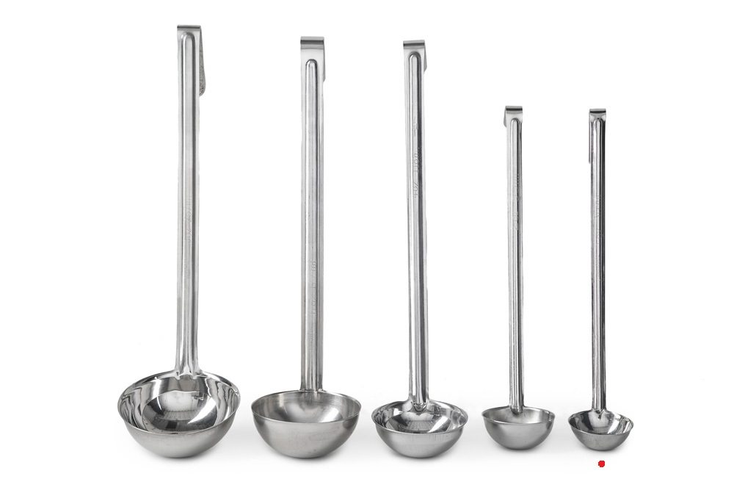  Ladle | Used to measure and portion liquids. The size or measurement in units of ounces is engraved on the handle of the ladle.
(C01/2-1-4)
CLASSIFICATION AND FUNCTION OF EQUIPMENT IN FOOD HANDLING

General Rules for the Selection of Electric/Gas Appliances
- Choose the appropriate size and model of tools according to their needs and uses to avoid waste.
- Choose quality and affordable tools.
- Make sure spare parts are easy to get and give priority to safety features.
- Have a warranty card and SIRIM or International Standards approval.
- Easy to get after sales service.
- The tool must be accompanied by a user manual as a guide.
- Make sure it is easy to get spare parts for the item.
- Also make sure these tools are easy to clean.

Cooking Utensil

There are different types of kitchen models on the market. It is heated either with gas or electricity or both, using electricity for the oven and gas burners. The kitchen design used at home is different from the design used in restaurants, canteens or dormitory kitchens. The stove is made of sheet steel and covered with porcelain, enamel or stainless steel. There are special finishes such as aluminium, copper and plastic. The burner is made of hard aluminium.

Range Tops Burner

Used to cook food using gas. The industrial gas stove has a cleaning pipe for easy washing. Choose a suitable kitchen design and model according to your needs and use, quality and made of materials that are not easy to rust, strong, and easy to clean. This kitchen has a stove/pot stand made of strong and heat-resistant steel.

Induction Stove

An electric stove is used to cook food by using a heating plate. Kitchen designs and models vary according to needs and uses. The electric stove must be of good quality and made of materials that are not easy to rust, strong, and easy to clean.
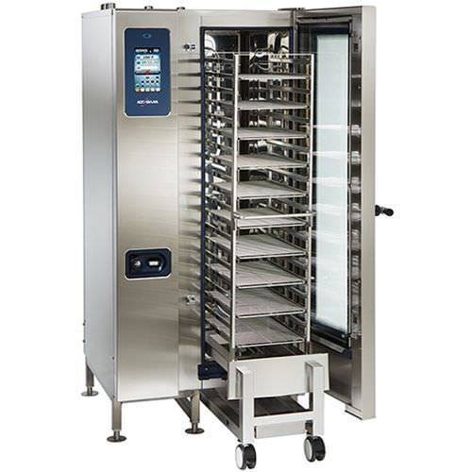
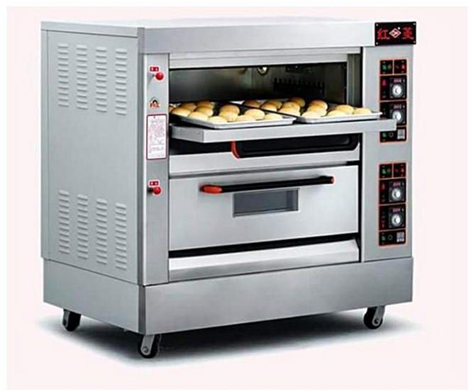
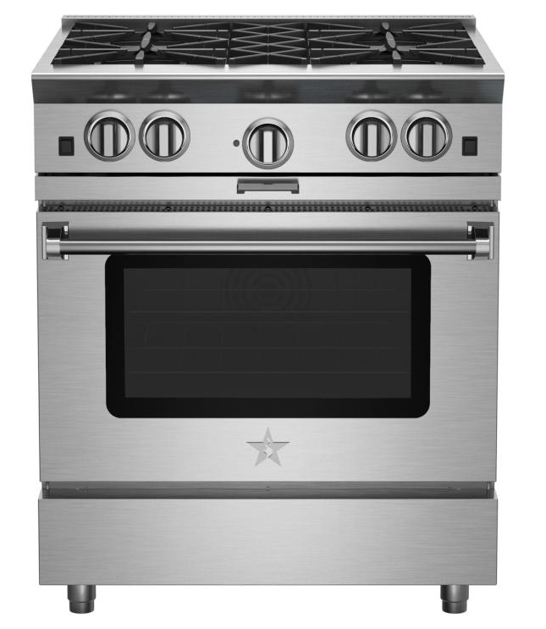
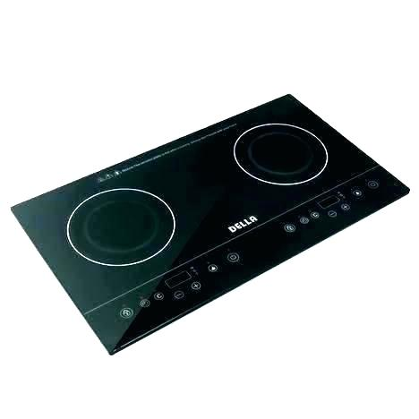
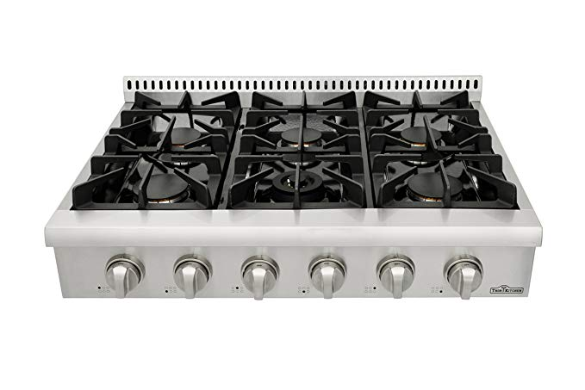
Industrial Gas Ranges with Oven
Industrial Combi Oven
Industrial 2-Deck Conventional Oven
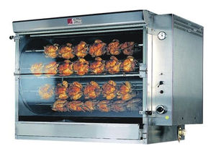
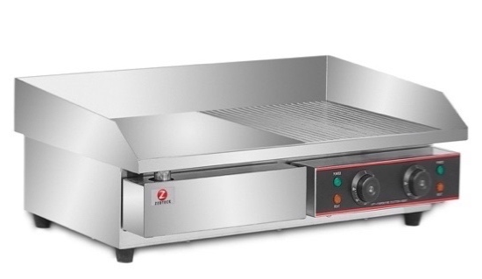
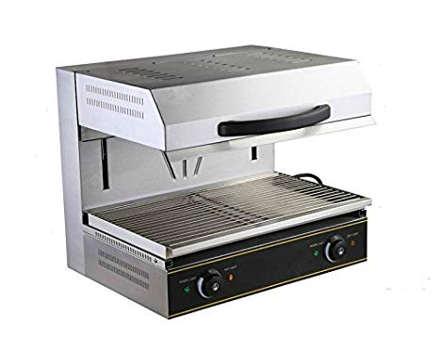
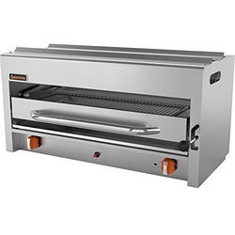
Oven
Conventional ovens work by heating the air in the closed space of the oven. Usually in industrial kitchen operations, there is an oven together with the kitchen unit. There is also a separate unit especially in the Pastry kitchen.

Stack ovens are ovens that stand alone, either one unit or more than one oven unit. Combi Oven or Combination
Steamer Oven is a type of oven that usually has three functions
- Convection oven
- Convection Steamer
- Combination of oven and steamer functions at the same time

Broiler
Broiler is sometimes called overhead broiler and its function is often mistaken for grill equipment. Broilers cook food using radiant heat from the top of the appliance. Food is usually placed in a pan and put under the broiler to cook. Food heating is by radiation or heat radiation from the top of the food.
Heavy-duty broiler produces high radiant heat and uses high electrical energy. The total heat temperature released by this device can reach 2,000 ̊ F (1,100 ̊ C).

Salamander
Salamanders are smaller broiler tools that function to heat food (browning and glazing) in small quantities compared to broilers. Can also cook food like broiler tools because the function is the same.

Gridle
The griddle is heated by heat from the bottom with gas or electricity. The surface is flat and made of thick solid iron/cast iron steel. Griddles are used to fry food using a little oil such as burgers, steaks, sausages and eggs.

Rotisseries
Rotisserie broilers cook meat and poultry using radiant heat from heat panels generated from gas or electricity. Some categorize cooking using this tool as a roasting cooking technique, but the cooking principle of broiling is more accurate because these tools use infrared heat. Cooking using this tool is usually used for grilling chicken / poultry, but practically this tool can also grill other ingredients such as beef and lamb.
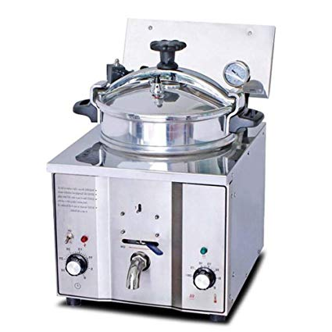
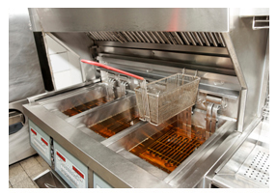
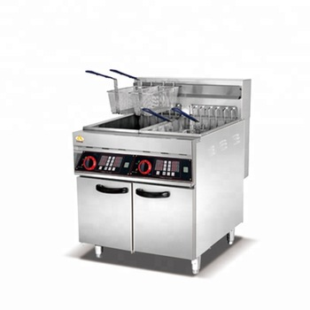
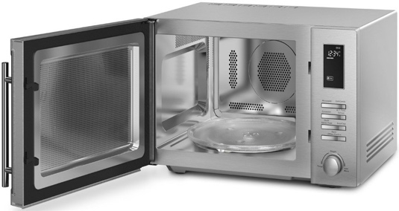
Commercial Pressure Fryer Cooker
Automatic Deep Fat Fryer
Gas Deep Fat Fryer
Microwave

A microwave oven cooks food using the energy carried by the waves. A type of voltage valve called a magnetron drives microwaves with a high repetition rate and also short-wavelength electro-magnetic waves.
Foods containing water are placed in the microwave oven. The molecules in the food move quickly and heat is released and cooks the food. Used to heat food, cook and defrost food. If it is used correctly, cooking using this oven is very fast and saves up to 75% of the time it takes to cook normally and can reduce energy. Food cooking time and quantity of food cooked.

Deep Fat Fryer

Used to fry large amounts of food to get even frying results. Usually, it has a thermostat that can turn off or slow down the fire once the oil reaches a high level.

There are three types of deep fryers

Gas Deep Fat Fryer
Standard deep fryers use gas or electric fuel.

Automatic Deep Fat Fryer
Automatic deep fat fryers have an automatic time-determining device that lifts the fryer basket as soon as the food is cooked. This fryer is very useful especially for kitchens that are always busy.

Commercial Pressure Fryer Cooker
Pressure-deep fryers where a thick metal cover is used to cover the fryer while food is being fried. Food is faster. This tool is heated using gas or electricity. There is a fryer attached at the bottom with a filter to filter food waste while frying.
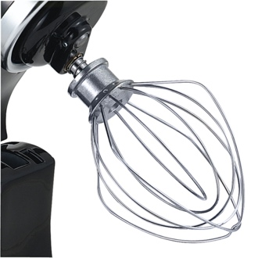 | Wire Whip or Balloon Whisk.  Used to mix liquid and soft dough while adding air such as sponge cake, meringue, batter and whipped cream. The speed used is maximum
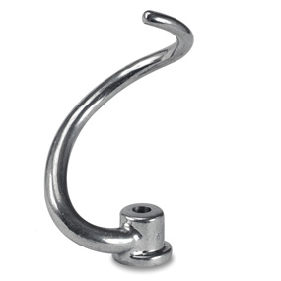 | Dough arm or dough hook.  Used to mix and knead hard or thick dough such as yeast dough and roti canai dough. Speed used number 1.
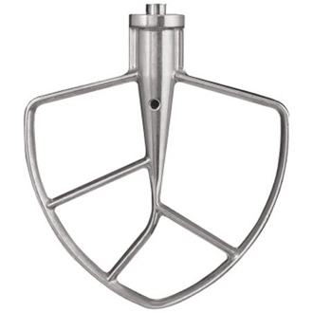 | Paddle or Beater  Used to mix dough that has a medium viscosity such as swirl cake dough, choux pastry dough and short pastry dough. The speed used when turning the dough should be moderate
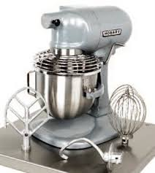
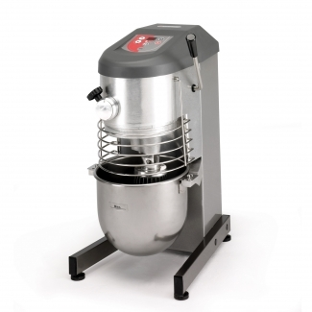
This tool is used to mix cakes, beat eggs and knead dough. Mixing bowls and mixing tools of different shapes and uses are included. Made of high quality material and easy to clean. There are three types of mixers;

Mixer 4-20 liters
Stand Mixer 20-100 liters
(C01/2-1-5)
PROCESSING EQUIPMENT

Food processing equipment is widely used in food preparation because it saves time and energy while reducing the number of kitchen workers.

Mixer
Available in two forms with loads as follows;

Food Cutter

Food cutter or rotation chopper, also known as buffalo chopper, is usually used for chopping food. Food is placed in a special bowl that comes with this tool. Food will be chopped in rotation using a pair of knives found in the tool.

Slicer
A slicer is a necessary tool to cut food evenly compared to slicing by hand. Most slicers are manually operated to slice food.

Blender

Food blender jugs are made of glass, plastic or stainless steel and have metric measurements. The size of the jug capacity is usually 1 liter. Used for making fruit juice, crushing and vegetables, chopping beans, grinding chillies, making purees and sauces, mixing batter and making mayonnaise. Has the facility to control the speed of the motor and is equipped with a specially formed stainless steel blade.

Hand Blender

Hand blenders have a more flexible shape and use, compared to regular blenders. Basically, hand blenders are more flexible, because they are light and can be carried anywhere easily. The hand blender has a long handle, useful for crushing food in a deep container, both in small and large amounts.

Food Processor

Available in various sizes from 2-4 litres up to 30-45 litres. Uses for grinding, cutting, kneading, slicing vegetables, mixing dough, liquid grinding for purees, soups, sauces, chopping meat, deboned fish, food dry such as nuts, coconuts and others. It has the facility to control speed and there is an inter-lock safety device. There are also blades used for grating, cutting, slicing, chopping and shredding.

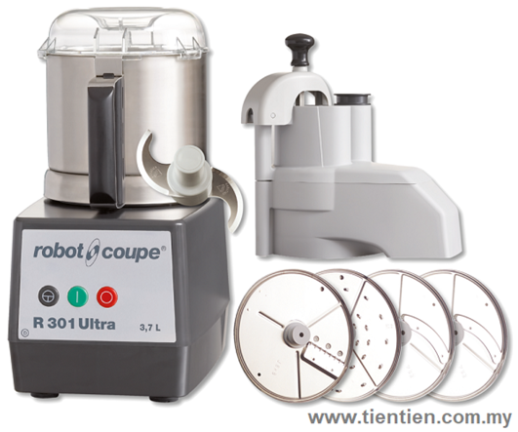
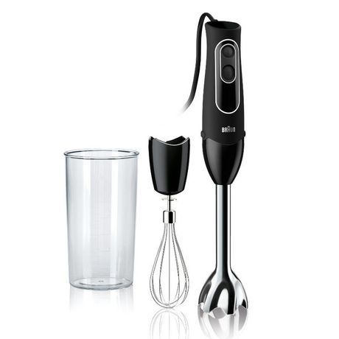
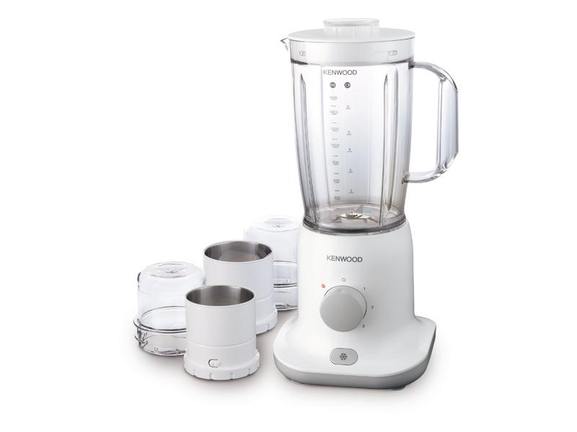
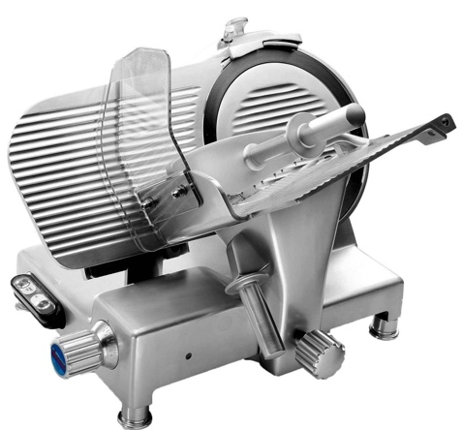
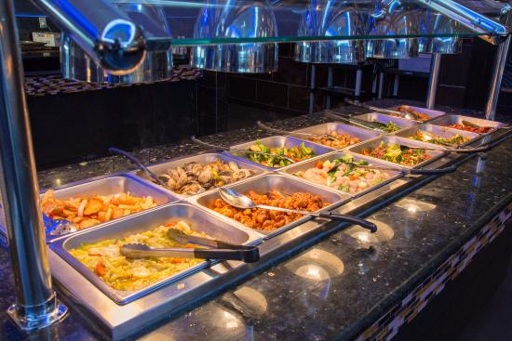
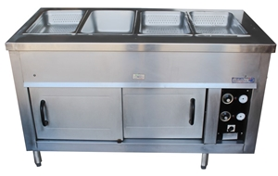
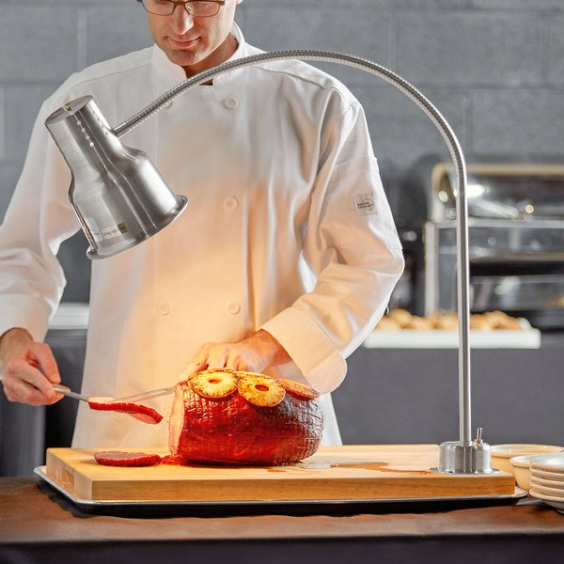
(C01/2-1-5)
HOT FOOD HOLDING EQUIPMENT

There are several equipment used to handle hot food to be served to customers. The equipment is designed to handle food at temperatures of 136 ̊ F ( 57 ̊ C) above to prevent the growth of bacteria in the food. Because the food placed in these tools is always heated, the food is continuously cooked slowly. This process gives side effects to the cooking such as the food becomes dry and the taste of the food becomes saltier. It is recommended that food is not stored for too long in these devices.

Steam Tables

This table is usually found in the buffet area, whether in a hotel, cafeteria or restaurant. Food is placed in a standard sized insert and there is hot water steam inside. Steam or hot water vapor is used to heat food for a long time. Always check the temperature of the utensils and check that the food does not dry out during serving.

Bain Marie

Bain-marie is a tool that uses a Hot Water Bath as a food heater. These tools usually use gas or electricity sources to heat the water in the tools. It has various sizes and shapes. This device is used to maintain the temperature of food so that it is always hot when served. Usually, this tool is used in the kitchen compared to the Steam table and is used as a food serving tool for example for buffet service.

Overhead Infrared Lamps
A type of food heating device that is used in the kitchen and also at the table in the restaurant. Food is placed under the light of an infrared lamp to be heated. Usually food such as grilled / grilled meat is placed on these tools. Food easily becomes dry if it is too long exposed under the infra heat.
Steam Table
Bain Marie
Overhead Infrared Lamps

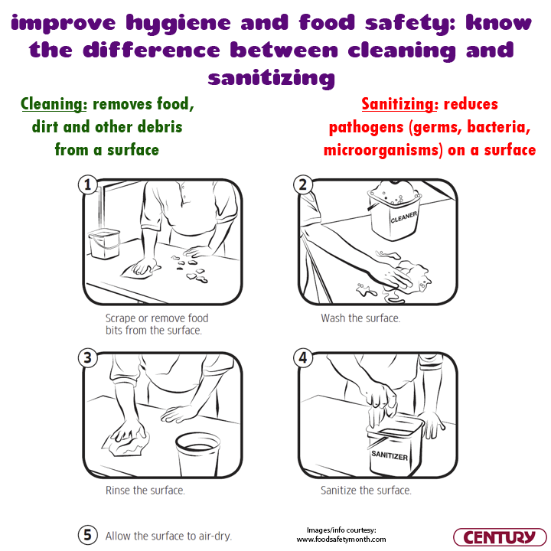
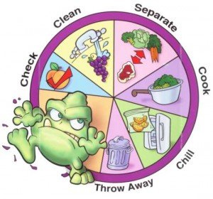
(C01/2-2)
SANITATION NEEDS IN THE WORKPLACE
(C01/2-2-1)
FOOD HANDLING TEMPERATURE

Sanitation means the practice of cleanliness which includes aspects of personal hygiene, workplace cleanliness and food hygiene. It aims to prevent food contamination that can cause food borne diseases.

Collection | Item Examples | Disposing the waste
Organic Trash | - Vegetable waste, fruit skins, animal skins and hairs, fish scales, bones, paper, wood pulp, cloth, liquid food scraps.  - Wastewater  - Excess oil | - Put the trash in a plastic bag, tie it up and throw it in a trash can with a lid.  - Liquid waste is dumped directly into sinks, longways or oil traps.  - Wastewater must be drained into the longbow.  - Disposed of in plastic, disposed of in a trash can or poured into a dug hole.
Non Organic Trash | Metal, glass, patchwork, plastic, tin. | - Discarded in plastic waste, tied up and disposed of in a trash can.  - Planted in a hole in the ground.  - Recirculated.
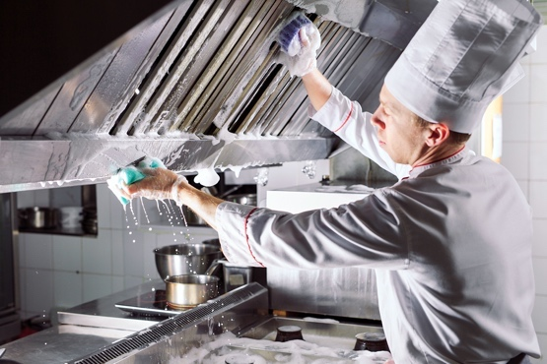
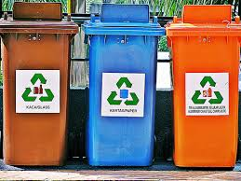
Sanitation

The kitchen area is an important workspace because this is where food is prepared, cooked and served. The cleanliness of this space ensures that the food provided is free from microbial contamination. Cleaning work can be carried out in two conditions namely daily cleaning and periodic cleaning. Workbenches, floors and sinks need daily cleaning while doors, windows, ceilings and storage cubicles need regular cleaning.

Garbage Disposal

Breakfast waste is waste material that is not needed either in solid or liquid form. Breakfast waste needs to be disposed of after every charity work. Garbage that is not disposed of properly leads to the breeding of insects such as flies, and cockroaches or destructive animals such as rats.

There are two collections of waste, namely organic waste and non-organic waste.
The government has now implemented the re-circle program. To make this program a success, different original recycling bins are provided for several types of non-organic waste.

BROWN color barrel: glass.
BLUE color barrel: paper.
ORANGE color tin: aluminum and plastic tin.

(C01/2-3)
MANUAL AND MECHANICAL WASHING

(C01/2-3-1)
WASHING PROCESS
The process of washing utensils such as dishes and dishes is very important in food service operations to ensure sanitation and hygiene. The washing area consists of three (3) sub-sections where each part is controlled by the steward (if it involves a large food premise):
Scraping is the process of removing food residue found on dirty utensils, known as pre-washing. Next, it is placed on a rack or tray for dishwashing machine washing or for hand washing. Whether the washing work is done by machine or conventional methods, the process that is followed is the same, namely; washing, rinsing and sanitizing.

The work of washing utensils, dishes and bowls includes: removing food scraps from the dining table, receiving and arranging utensils and being ready to wash, washing, drying and then storing utensils.

There are 3 water temperatures needed in the process of washing dishes, bowls and cooking utensils, namely:

Pre-washing
The process of removing food residue and melting fat and oil on the surface of the tool requires a hot water temperature of 48°C-50°C.

Washing
The temperature of 60°C is hot enough for an effective cleaning action.

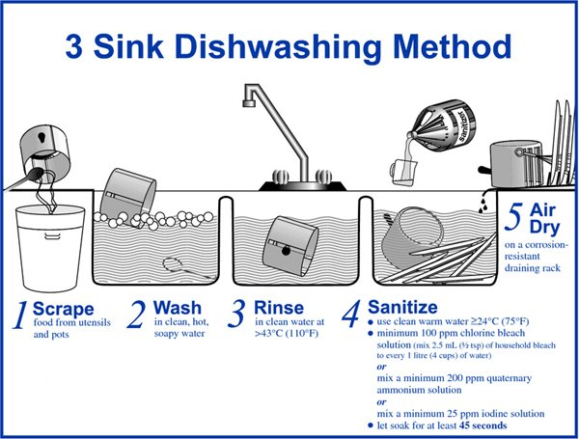
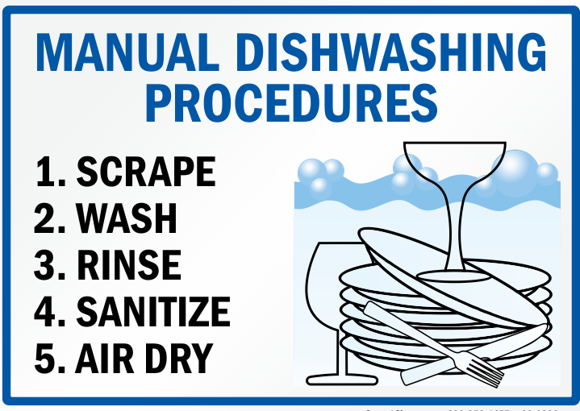
Sanitation
Rinse the washed equipment with water at 180°C for 10 seconds. Most bacteria will die at a temperature of at least 170°C rinsed for 30 seconds or more. In smaller hotels, the cleaning work is done manually.

*** Whether washing dishes, bowls and utensils using machines or conventional methods, the process is the same.

(C01/2-3-2)
WASHING PROCESS
- Leftovers are thrown into the trash first, or collected in one dish.
- The bowls are collected by one cup only. It's best not to put it in the sink but next to the sink. If space is not available, leave it on the floor or on a nearby table/counter.
- First of all, make sure that the dish rack is empty. Dishes and bowls have been stored neatly in their respective places. So, dry dishes will not get wet again or there will be a problem of not having enough space to dry the dishes to be washed.
- The cup is washed first because it is less oily and can save soap. The cup that is washed first will also not be contaminated by the smell of food made from palm oil, curry and so on.
- Then followed by washing the plates and followed by the bowls.
- Finally spoons of forks and pots and pans.
- Then the arrangement in the dish rack also follows the category of cups, plates and then bowls. The scattered arrangement will take up space too and complicate us to retrieve it when needed.
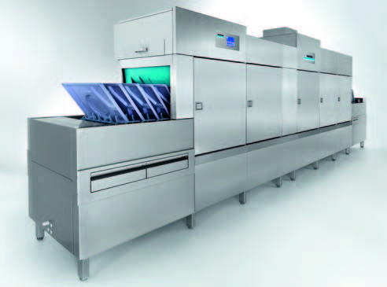
(C01/2-3-3)
MECHANICAL DISH WASHING
In contrast to hand/manual washing which requires a lot of physical work and curvature to remove the impression, mechanical dishwashers wash by sprinkling hot water (55°C - 65°C or 130°F - 150°F) onto dishes.

Through this mechanical method, high alkaline washing agents can be used because they are not exposed to human skin. In fact, some dishwashing ingredients also contain a heat element to allow dishes to dry quickly.

Mechanical washing procedure:
- Dispose of food waste and rinse utensils
- Place the equipment in the special rack and make sure the surface of the dirty tool faces the spray area.
- Start the engine
- Ensure the sanitizing temperature of the equipment:
- Temperature 180 F for heat washers
- Temperature 140 F for Chemical Disinfectant

Air dry and check the tools that were cleaned earlier. Make sure not to touch the surface of the tool being cleaned directly.

(C01/2-4)
SANITATION AND CLEANING EQUIPMENT AND WORK ROOM

- Equipment used to prepare, cook and serve food should be clean.
- Glass utensils such as plates, bowls, plates, cups, teapots and so on should be clean, not cracked or chipped.
- Metal utensils such as pots, cauldrons, spoons, spatulas, kettles, pitchers, forks and food tongs should be free from rust.
- Cutting boards should be clean, and used separately for raw food and for cooked food.
- Wooden utensils such as chopping boards and wooden spoons should be wiped dry before storing.
- Equipment such as sieves and kneading machines should be stored dry.
- Refrigerators should be cleaned and packed after class practice.
- If there are insects such as ants, cockroaches and signs of a rat attack, immediately report it to the teacher.
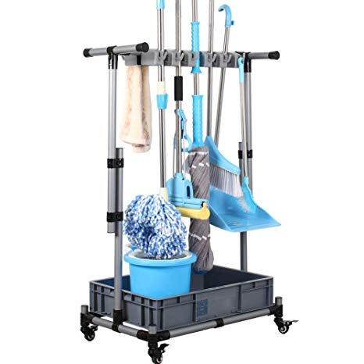
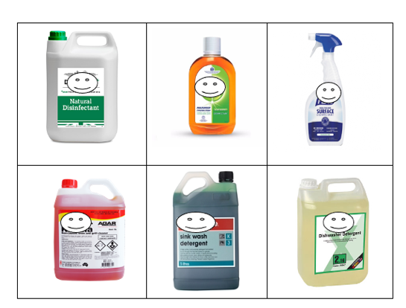
- Use the correct detergent for washing dishes, dishes, kitchen cloths, and washing worktops and kitchen surfaces.
- Cleaning equipment such as sweepers, mops, buckets and detergents need to be stored in a special place.

(C01/2-4-1)
SANITATION PROCEDURE AND CLEANING WORK ROOM

- Unplug electrical equipment before cleaning.
- Disassemble / remove / disassemble equipment
- All equipment must be cleaned first.
- Wash all surfaces that touch food using a washing solution and a clean cloth.
- Re-sanitize the surface with double the sanitizing agent using a clean cloth (The cloth is for this purpose only)
- Let dry
- Repack the workspace

(C01/2-5)
SANITATION, SAFETY AND CLEANLINESS OF THE WORKSPACE.

(C01/2-5-1)
SANITATION

Sanitation means hygiene practices that include aspects of personal hygiene, workplace hygiene and food hygiene. It aims to prevent food contamination that can lead to infectious diseases (food borne disease).
4.2 Personal Sanitation.
Personal hygiene is very important to ensure health and also reflects the personality of each individual. Personal hygiene includes hair, face, teeth and mouth, nails and hands, body skin and clothes. Necessary items such as clothes, bath towels, combs, toothbrushes must be your own. Do not borrow or use other people's necessities.

(C01/2-5-2)
PERSONAL HYGIENE
Personal hygiene is very important to ensure health and also reflects the personality of each individual. Personal hygiene includes hair, face, teeth and mouth, nails and hands, body skin and clothes. Good personal hygiene can prevent food poisoning.

Bacteria that cause food poisoning can be on everyone – even healthy people. You can spread bacteria from yourself to the food if you touch your nose, mouth, hair, or your clothes, and then food.

Good personal hygiene also makes good business sense. Customers like to see food-handling staff who take hygiene seriously and practice safe food handling.

Food handlers – Personal Hygiene Tips

To prevent food poisoning using good personal hygiene, follow these tips:
- Wash and dry your hands thoroughly before handling food, and wash and dry them again frequently during work
- Dry your hands with a clean towel, disposable paper towel or under an air dryer
- Never smoke, chew gum, spit, change a baby’s nappy or eat in a food handling or food storage area
- Never cough or sneeze over food, or where food is being prepared or stored
- Wear clean protective clothing, such as an apron
- Keep your spare clothes and other personal items (including mobile phones) away from where food is stored and prepared
- Tie back or cover long hair
- Keep fingernails short so they are easy to clean, and don’t wear nail polish because it can chip into the food
- Avoid wearing jewelry, or only wear plain-banded rings and sleeper earrings
- Completely cover all cuts and wounds with a wound strip or bandage (brightly colored waterproof bandages are recommended)
- Wear disposable gloves over the top of the wound strip if you have wounds on your hands
- Change disposable gloves regularly
- Advise your supervisor if you feel unwell, and don’t handle food.

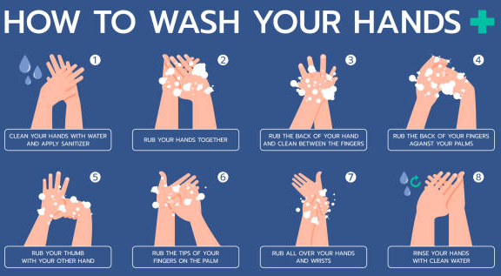
Food handlers – Handwashing
Thoroughly washing your hands reduces the chance of contaminating food with bacteria from yourself.

Wash your hands with soap and warm water, and don’t forget the backs of your hands, wrists, between your fingers and under your fingernails.

Thoroughly dry your hands immediately after you wash them. Always dry your hands with a clean towel, disposable paper towel or under an air dryer. The important thing is to make sure your hands are completely dry. Never use a tea towel or your clothes to dry your hands.
before putting on gloves.

Wash your hands after:
- Going to the toilet
- Handling raw food
- Blowing your nose
- Handling garbage
- Touching your ears, nose, mouth or other parts of the body
- Smoking
- Every break
- Handling animals.

If you are wearing disposable gloves, change them regularly – at the same times you would normally wash your hands if you weren’t wearing gloves. Wash and dry your hands before putting on gloves.

Food handler health and working
Food handlers may contaminate food, so employers and employees must be careful to ensure that no illness is passed on by those working in the industry.
You should not go work if you are vomiting or have diarrhea.

Don’t return to work until your symptoms have stopped for 48 hours. If you are unsure, you should contact your doctor for advice.

Do not go to work if you sick with an illness that is likely to be transmitted through food. Such illnesses include gastroenteritis (often called ‘gastro’) – including viral gastroenteritis (norovirus or rotavirus) – hepatitis A and hepatitis E, sore throat with fever, and fever with jaundice.

You must advise your supervisor if you are feeling unwell, including when suffering from a cold, flu, and sties and other eye infections.

(C01/2-5-3)
SAFETY

Safety aspects in the workplace
To maintain safety, the rules set for the workspace must be followed. Accidents can happen when preparing food, cooking, or serving food. Handling equipment such as knives, pots, and electrical equipment can cause accidents if care is not taken. Positive behavioral practices should be implemented when working in the kitchen or workplace.

Workspace rules that must be followed:
- Wear clothes that are suitable for the task to be carried out.
- Practice a calm and systematic attitude when doing work.
- Do not run and joke while working.
- Do not eat, drink and smoke in the work area.
- Make sure the doors and windows are open so that the air flow is good and smooth.
- Use a potholder cloth or dry oven mitts when handling hot tools.
- Use a can or bottle opener properly to prevent hand injuries.
- Be careful when opening the lid of a hot pot or steamer to avoid touching your face or hands with hot steam.
- Use a special ladder or bench to pick up items stored in high places.

- If there is spilled food or liquid on the floor, wipe it up immediately to avoid accidents.
- Turn off taps, switches, or stoves when not in use. Avoid wasting water, electricity, or fuel.
- Make sure that the equipment, worktable, and floor are in a clean condition when the practical is finished.
- Make sure the electricity, gas and water sources are turned off before leaving the workshop.
- Report and document any equipment damage, electrical wiring, or broken glassware for further action.
- Use and carry sharp tools carefully and safely. If you want to hand out a sharp tool, point the handle towards the person who will receive it.

(C01/2-5-4)
WORKSPACE CLEANLINESS

Kitchen appliances and utensils
- kitchen tools and equipment are thoroughly washed before and after use
- Stored in a clean and orderly place
- Must be handled in the right way
- The bottom of the plate should be washed clean
- Do not use wooden utensils such as cutting boards as they are difficult to clean and wood chips can be left on food.
- Equipment that is in an imperfect condition such as broken, rusty, etc., and not cleaned according to the correct method will reduce the effectiveness of the food preparation process.
- Wooden equipment can be a breeding ground for fungi and germs because it absorbs water and is difficult to clean. This can also cause food contamination if fungi or toxins from fungi and germs enter the food.

Examples of equipment that failed to work because it was not cleaned:

- Ovens that have traces of dirt that are not cleaned will form a layer of dirt. This will reduce the rate of heat flow and affect the function of the oven and further cause the food to not be cooked enough
- Filters that have thick and rusty dirt prevent the process of filtering raw materials such as coconut milk. Rust from filter iron can also cause food poisoning when it contaminates food
- Broken pieces of equipment easily fall into the food and cause contamination in the food

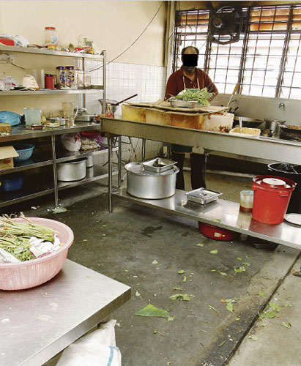
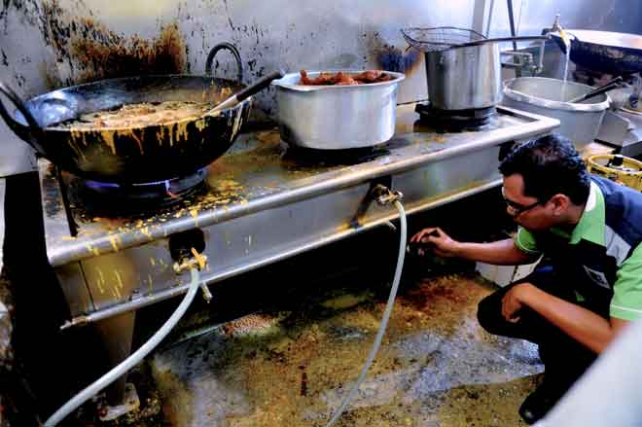
- Rotten wooden doors where germs can breed and if left unchecked, pests can enter the cracks between the rotting wood
- A ceiling that has come off and can cause injury if it falls. Debris from the ceiling can fall and contaminate the food below
- Dirty floors and loose tiles. This causes the floor to be uneven and traps dirt and is difficult to clean
- Clogged and dirty drainage systems can attract pests, collect dirt, and create unpleasant odors in the workplaces.

Food handler workplace
- The building or workplace must be in good condition, easy to maintain and clean.
- For food stalls, it is recommended to use stainless steel as the basic structure of food contact surfaces. Avoid using wood as it rots easily.
- Construction design should be simple, smooth, and perfect.
- According to the Food Act 1983 and Food Regulations 1985, cleanliness of food workplace is mandatory. Dirty workplaces are acted and closed.
- If the workplaces are dirty, the possibility of food contamination is high.
- Dirty workplaces will also face the problem of the presence of pests.
- Workplaces and equipment that are always looked after and maintained will remain in good condition for a long time.
- Pictures show dirty and poorly maintained premises structures:

Hygiene Aspect | Personal Hygiene
Hair

Nails

Uniform

Good Food Handler Practice

- Make sure the premises are always cleaned before and after business
- If possible, clean more often because dirt, dust and dust easily stick to utensils and food utensils
- Food served should always be covered and never leave food exposed
- Make sure raw materials are stored in a closed and suitable place to prevent pests from entering the premises.
- No vermin are allowed in the food premises.
- Examples of pests are cockroaches, flies, rats, cats, birds, dogs and others.

Preventive measures:

- Ensure there are no openings or holes in the food premises - to prevent pests from entering.
- Ensure the food premises are always clean.
- Ensure drains and drainage are not blocked and in good condition.
- Ensure that the trash can is always covered, and the trash is tied tightly.

Question

1. Give two (2) workspace rules that you need to follow.
________________________________________________________________________________________________________________________________________________________________________________________________________________________________________________________________________

2. Give one (1) personal hygiene practice for each aspect below:

Dusbin Colour | Garbage Material/Category
Brown

Blue

Orange

Equipment | Uses
Thermometer
Microwave oven
Collender
5. Give two (2) general rules for choosing electrical goods.
__________________________________________________________________________________________________________________________________________________________________________________________________________________________________________________________________________________

6. Give one (1) general function of the following tools:
3. What does sanitation mean?
__________________________________________________________________________________________________________________________________________________________________________________________________________________________________________________________________________________________

4. State the waste material according to the original cycle color category:
[Title]
Apply Kitchen Food Safety Procedures

This explanatory paper aims to provide understanding and knowledge to trainees to store food items based on the First In First Out (FIFO) system and state the objectives and principles of receiving and storing food items according to the correct method.

JABATAN PEMBANGUNAN KEMAHIRAN
KEMENTERIAN SUMBER MANUSIA
ARAS 7 & 8 BLOK D4, KOMPLEKS D
PUSAT PENTADBIRAN KERAJAAN PERSEKUTUAN
62502 PUTRAJAYA

EXPLANATORY PAPER

PROGRAM CODE AND NAME | I56-005-2:2022 FOOD PREPARATION AND PRODUCTION
LEVEL | L2
NO. AND UNIT TITLE OF COMPETENCY | C01: Practice kitchen hygiene and safety procedure.
NO. AND WORK ACTIVITY STATEMENT | - CARRY OUT KITCHEN PERSONAL HYGIENE  - APPLY KITCHEN WORKSTATION SAFETY  - APPLY KITCHEN FOOD SAFETY PROCEDURES
NO. CODE | I561-005-2:2022 - C01/P(3/3) | PAGE: 65 - 79

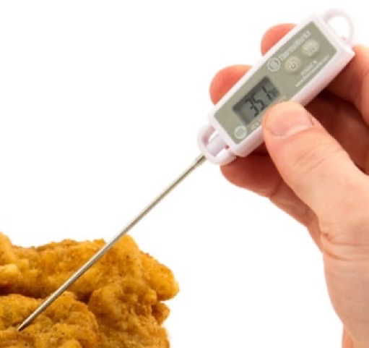
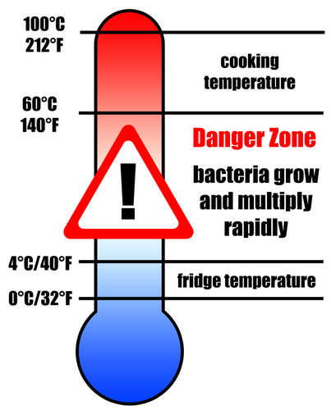
(C01/3-0)
KITCHEN FOOD SAFETY PROCEDURES

(C01/3-1)
Important basics when handling and preparing food
- Wash your hands with soap and clean water.
- Use clean hardware and equipment.
- Store cold food at a temperature of less than 4°C.
- Storing hot food at temperatures above 60°C.
- Cooks food perfectly.
- Separate storage areas for cooked food and raw food.

(C01/3-1-1)
FOOD HANDLING TEMPERATURE

One of the important aspects of ensuring food is safe to eat is food temperature control. There are three temperature control zones:

Destruction zone (74°C - 100°C).
• At this temperature most of the microorganisms can be destroyed.

Danger zone (5°C - 63°C).
• This temperature includes room temperature and normal body temperature.
• Microorganism reproduction is active at this temperature.

Inactive zone (4°C – (-18) °C).
• Refrigerator temperatures below 4°C will slow down the growth of microorganisms.
• Freezing temperatures below -18°C cause the growth of microorganisms to stop.
• If frozen food is thawed, the microorganisms will become active again.

Cooked food (especially red and white meat) is said to be safe if it reaches an internal temperature capable of destroying harmful microorganisms. This can be done by using a food thermometer.
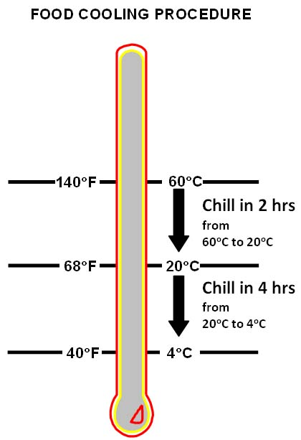
(C01/3-1-2)
FOOD COOLING METHODS
Many of us think that when we cook at a high temperature (over 100̊ C), all pathogens or organisms that can harm food have died. But the fact is that it is not true. Some pathogens or organisms are resistant to high temperatures. This means that even if food is cooked at a high temperature, there is still a possibility that the food will be contaminated with pathogens after cooking. Ipathogens or organisms become active when the food is in the danger zone. For this reason, knowledge about food cooling procedures is very important for food handlers to ensure that food is safe from contamination.

Food storage with cooling
Two-Stage Cooling Method
Cooling food from 140 ̊ F (60 ̊ C) to 70 ̊ F (21 ̊ C) no more than 2 hours, after the first stage of cooling, food is cooled again for 4 hours at a temperature of 70 ̊ F (21 ̊ C) to 40 ̊ F ( 4 ̊ C). The total cooling time of the food is not more than 6 hours

One-Stage Cooling Method
- Refrigerate food to a temperature of 40 ̊ F ( 4 ̊ C) for no more than 4 hours.
- If the food does not cool to a temperature of 70 ̊ F (21 ̊ C) within 2 hours, the food should be heated to a high temperature of 165 ̊ F (74 ̊ C) for at least 15 seconds and cooled again.
- One stage cooling method should be implemented for foods categorized as Potentially hazardous food (PHF) that are placed at room temperature.

Here are the ways to store food in the refrigeration method:
- Use stored food immediately.
- Wrap food in aluminum foil, plastic or store in an airtight container.
- Avoid storing food tightly so that the flow of cold air is not affected.
- Label food containers with their storage dates.

Three ways to defrost/thawing food
- Place frozen food in the chiller compartment
- Place in cold water (water should be changed every 30 minutes).
- Using a microwave oven (if you want to continue to use/ cook).
- Do not defrost at room temperature because it promotes the growth of microorganisms.

(C01/3-2)
BASIC PRINCIPLES OF RECEIVING FOOD
The correct reception and storage of food ingredients is important in food handling. It starts from receiving raw materials from suppliers, storing and distributing goods from the store to the kitchen departments. Each of these stages involves a recording process in writing or using a computer system (according to the specific organization).

The objective of doing the correct food reception and storage procedures is to ensure that the food used is of good quality and safe to eat.

(C01/3-2-1)
PRINCIPLES OF ACCEPTANCE OF FOODSTUFFS
Acceptance of food means checking the food sent by the supplier from the aspects of:
- Correct goods as requested.
- Correct quantity as requested.
- Quality (packaging condition, size, shape, colour, temperature).

The criteria above are used to determine whether the item is accepted or rejected. A visual inspection is performed for the physical aspects of the food items sent by the supplier.
Example:

Food containers and boxes.

- Packaging for food products is not damaged and leaking.
- If the food container has been damaged (broken, crushed, faded), the contents may have been exposed to food contamination.
- Make sure there are no signs of food contamination by pests, insects and birds.

Perishable items.

- Fresh Condition.
- No bad smell.
- Color change.

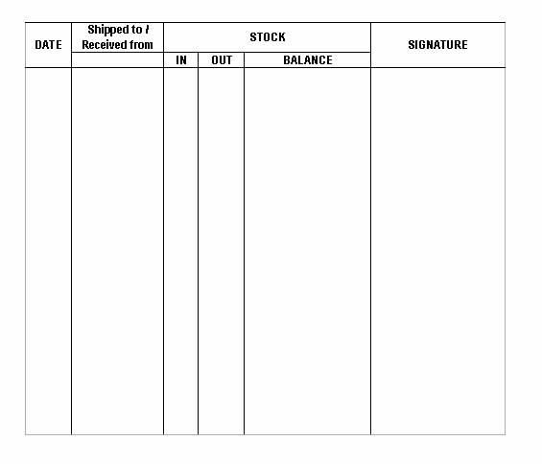
Canned products.

- Make sure there are no dents on the top and bottom of the can frame or on the inside of the can.
- Cans do not bubble.
- The can is not rusted or the surface creased.
- Not past the expiration date.

(C01/3-2-2)
5 BASIC STEPS ACCEPTANCE OF FOOD ITEMS
- Check and check with the purchase order.
- Check the invoice.
- Accept orders only if all quantity and quality specifications are met
- Complete the receipt record.
- Store food in a suitable storage area.

(C01/3-2-3)
FOOD ACCEPTANCE PROCEDURE (SOP).
- Prepare tools for the acceptance process (example: request note).
- Do a visual inspection of the delivered goods (packaging condition if there is damage).
- Check and record the temperature of frozen or refrigerated food.
- Check the quantity of goods delivered.
- Check the replaced items (if any).
- Reject items that do not meet the criteria and note them on the invoice.
- Sign the invoice.
- Label the date of receipt on the packaging.
- Store items in a suitable storage area.
- Record the stock in the inventory card.
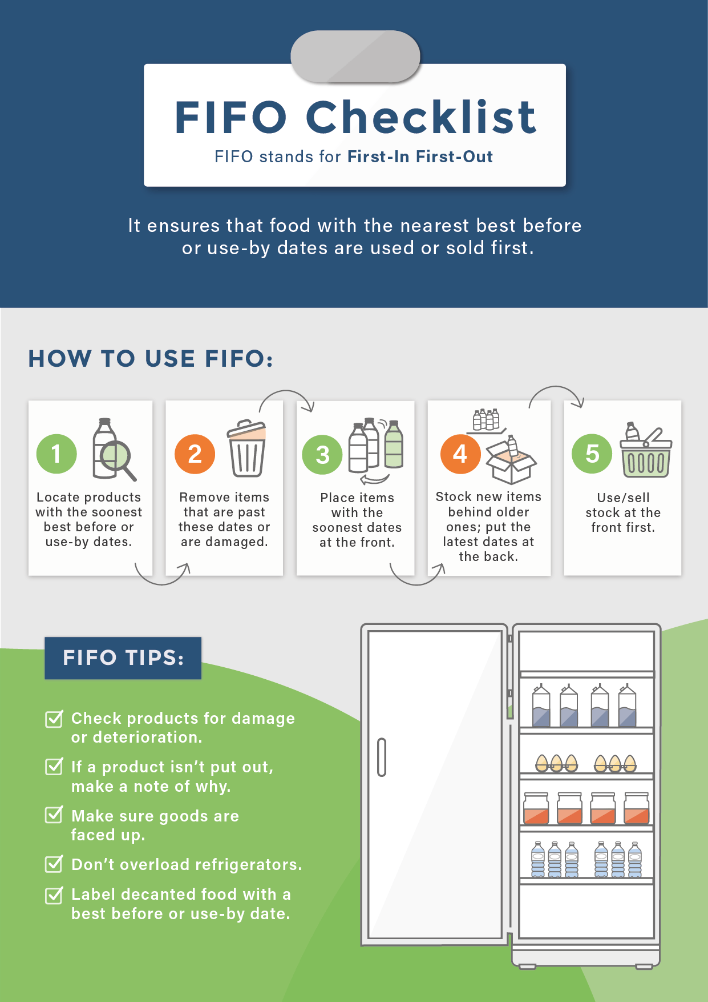
(C01/3-3)
FOOD STORAGE METHODS

(C01/3-3-1)
FIRST IN FIRST OUT (FIFO) SYSTEM

Food storage means placing the food received from the supplier in a suitable storage place. At this stage the principle of FIFO (First In, First Out) is applied. FIFO is a cycle system of food items currently in the storage stage. It explains the use of materials based on what comes in first is used first and what comes later must wait until the previous one has been used up. So, when this principle is practiced correctly, it can ensure that the food prepared is safe to eat and prevent waste due to food spoilage during the storage period. Next, the cost of raw materials can be saved.

Storage method according to First In First Out (FIFO)
- Store food by date
- Store food by type
- Arrange the perishable / almost expiring materials in front

FIFO process
- Mark the date / use of the bin card
- Coordinate
- Organize

5 steps to implement the FIFO procedure
- Identify food products that have an expiration date that is close to the date or types of food that spoil quickly such as vegetables and fruits.
- Dispose of goods that have expired or have signs of damage.
- Place or arrange items that are about to expire in the front row.
- Items that have just arrived / purchased are also confirmed to have an expiry date. New items and old expiration dates will be placed in the back row.
- Use the product / item in the front row first.

(C01/3-3-2)
DRY STORAGE
Dry storage store or main store for storing dry food such as grain, flour, spices, cooking oil, pasta and other suitable dry food. The food storage area must have the following characteristics:
• The location is close to the reception area and the kitchen.
• The area is sufficient (not too small or too large).
• Access is limited to store staff and management.

Dry storage store features
- The temperature is between 16°C - 21°C.
- Has smooth air ventilation.
- Limit sunlight but maintain sufficient light of 2-3 watts / square foot.
- Keep items away from walls and floors for air circulation and easy cleaning.
- Bulk goods are stored on pallets 6 – 7 inches off the floor.

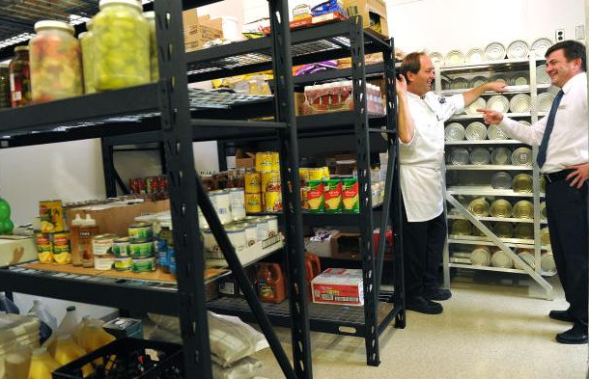
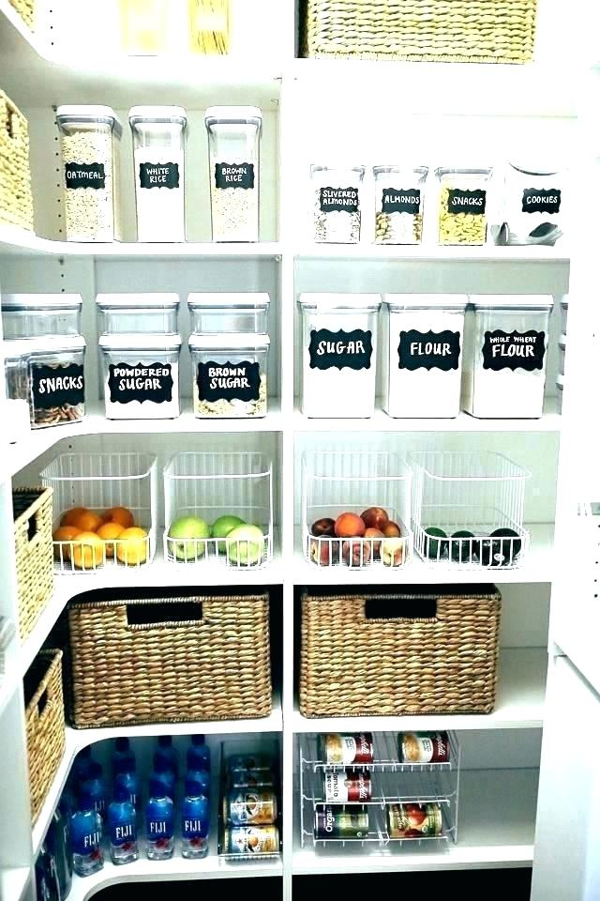
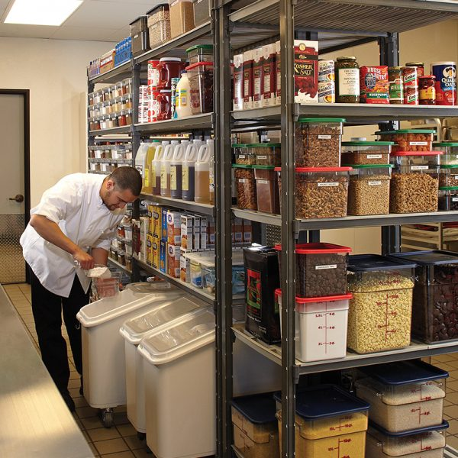
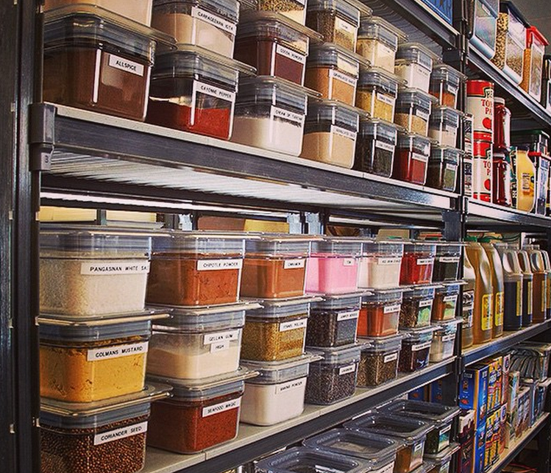
- Goods should be arranged on the shelves using the FIFO system.
- vii. The order of goods must be organized with a numbering or coding system.
- viii. Keep it easy to find and take inventory.
- ix. Grains in large packages or perishable items should be stored in metal or plastic containers that are tightly closed and labeled.
(C01/3-3-3)
FREEZER
Freezer storage temperature below -18ºC. Among the food products that need to be stored in the frozen storage room are meat, frozen food, ice cream and ice.

Aspects that need to be emphasized for frozen storage are:
- Food should be packed properly.
- Storing products according to the FIFO concept.
- Do not refreeze thawed products.
- Consider the use of a thermal gauge for the purpose of monitoring freezing temperatures.

Generally, this Freezer just refers to any room that is completely closed, with thermal insulation walls, supplied with continuous cold air and has a door that is able to block air from entering and exiting.

Storage guidelines in the Freezer

- The temperature should be at or below -18°C
- Used to store high protein foods such as meat, chicken, fish and seafood.
- Food that has been defrosted cannot be refrozen.
- Seafood needs to be stored separately from poultry and meat. This is to avoid cross contamination. (e.g. bacteria in chickens spread to fish because they use the same place to keep fish)
- Walk-in freezer is also suitable for storing frozen food.
- Frozen foods shall be stored frozen
- Raw and cooked food should be store separated
- To prevent freeze burn(explain)we can wrap
- Do not overload, need the air circulation
- Above floor at least 0.2 meters

(C01/3-3-4)
REFRIGERATOR/CHILLER ROOM
- Refrigerators are used to keep food cold but not for freezing.
- Used to store food other than high-protein animal food and frozen items such as fresh fruit, dairy products, vegetables and any high-protein frozen animal food that needs to be defrosted.
- Store all non-perishable ingredients in a chiller at a temperature of 0ºC to 4ºC. Usually, the ingredients stored in the chiller are at different temperatures. Make sure this refrigerator is not in a dangerous temperature which helps the breeding of bacteria.
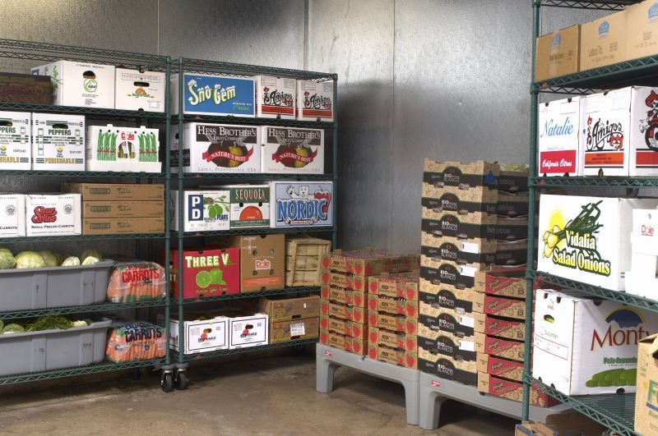
- Make sure the refrigerator door is always closed and only opened to take or take-out food.
- Separate raw food from cooked food.
- Make sure the Refrigerator is cleaned regularly, at least once a week.
- Separate cooked food from raw food. Make sure cooked food is placed on top and raw food is placed on the bottom.
- Make sure all food is covered/wrapped before being placed in the Refrigerator as a hygiene measure.

Principles of proper refrigerator storage

- The temperature should be between 0°C - 5°C
- High-risk foods and prepared vegetables shall be stored chilled
- Ready-to-eat food should not store together with raw ingredients
- Never store raw ingredients over ready-to-eat food
- Separate and labelled the allergic ingredients
- Do not over pack, need the air circulation
- Above floor at least 0.2 meters
- According to the concept of "First In First Out"(FIFO).
- Food is stored in small containers to speed up cooling.
- If there is no choice, raw food should be placed at the bottom to avoid cross contamination.

Arrangement of food in the refrigerator

- Food spoils easily in the freezer and keep it covered
- Cooked food is stored on the top shelf in a cold room and make sure it is covered
- Processed foods such as condensed milk, cheese and cut fruits are placed on the 2nd shelf and make sure they are covered
- Defrosted raw materials are placed on the lowest shelf and make sure they are covered
- Vegetables and fruits are kept at the bottom and keep covered
- The storage space in the refrigerator door is filled with bottled drinks, sauces and so on.
- Eggs should be kept in a dedicated room.
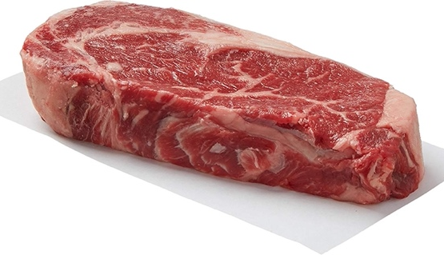
(C01/3-4)
FOOD STORAGE ACCORDING TO THE RIGHT METHOD

(C01/3-4-1)
VEGETABLES AND FRUITS
- If you have a refrigerator, fruits and vegetables should be stored at the bottom or a special section for vegetables to maintain moisture in the food
- Vegetables should be wrapped in plastic wrap to last longer. Fruits such as bananas need to be stored in a cool and dry place to prevent the skin from becoming bruised.
- Excess canned food should be transferred in another rust-resistant container and kept in the refrigerator to avoid food poisoning.
- Root vegetables such as potatoes, sweet potatoes and onions need to be stored in a dry place with good ventilation to prevent the vegetables from sprouting. Usually these root vegetables are stored in netted containers.
- Vegetables should be stored in appropriate containers and arranged on shelves. While vegetables and fruits that have been damaged need to be removed from the store.

(C01/3-4-2)
MEAT
Raw meat
- Meat such as goat and beef should be wiped with a clean cloth, wrapped and divided into smaller sizes for each dish and stored in the freezer. The average temperature in this freezer room is below 0ºC
- Avoid raw meat coming into contact with cooked meat because raw meat contains bacteria that can be transferred to the cooked meat.

Frozen Meat
- Frozen meat must be stored all the time in the freezer section at a temperature below 0̊ C.
- If you want to use it, frozen meat needs to go through the defrosting process (thawing) by opening the package of the meat. Then the meat needs to be kept in the chiller overnight.
- It is forbidden to store defrosted meat back in the freezer to prevent the growth of bacteria.

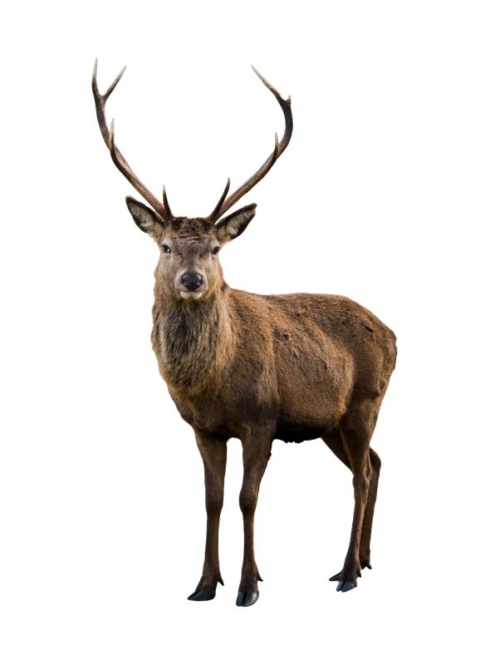
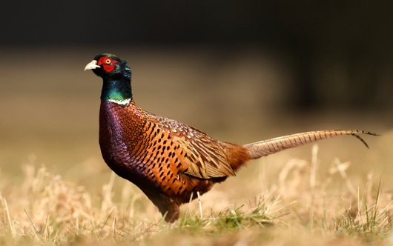
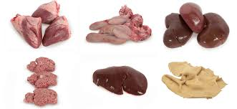
Wild Rabbit
Pheasant
Deer
Organ
It is an organ in the animal body such as the liver, spleen, kidney, tongue and stomach
- It should be wrapped first before freezing and not tightly closed.
- Organ should not be stored for more than 1 or 2 days. Preferably used on the same day.

Cooked Meat
- It is very important for us to cool the meat dish first before storing it in the refrigerator
- Meat dishes can be stored in the chiller for only 3 or 4 days.

(C01/3-4-3)
POULTRY AND GAMES

Poultry
- Can be termed any type of bird (usually chicken) that is specially raised to eat its meat and eggs.
- Types of poultry
  - Chicken
  - Duck
  - Goose
  - Turkey
  - Ostrich

Games
Can be categorized in the group of game animals that can be eaten. Divided into 2 namely:
- Animals that have fronds such as quails, pigeons
- Furry animals such as deer, deer, rabbits,

Poultry is very perishable. In general, the way to store poultry and game is not much different compared to meat. However, poultry should not be kept in the freezer for too long compared to meat.

(C01/3-4-4)
FISH AND SEAFOOD

Storing fish / Sea corals
- Fresh fish / corals are easy to spoil and should be cooked on the same day we buy them.
- fish / Seafood can be kept for 1-2 days in the freezer
- Usually, the fish sold in the market is always placed on a piece of stone water so that the fish does not rot quickly.
- Fish should be wrapped in plastic or a closed container before being stored to last longer, and it should be separated according to the types of fish.

(C01/3-4-5)
ICE-CREAM AND FROZEN FOODS
- Example of frozen food; sausage, nuggets, and others.
- This type of food should be stored immediately.
- The temperature in the freezer must be at -20ºC
- Use a rotation system (FIFO)
- Make sure the door of the chest freezer is always closed

(C01/3-5)
HOT AND COLD FOOD HANDLING

(C01/3-5-1)
Four-Hour Rule
For food safety, four-hour rules must be followed. Do not leave your food exposed in the danger zone (32̊ F to 135̊ F) as bacteria thrive in this temperature range. Make sure food is not handled for more than four hours in the danger zone

Basic guide to the Four-Hour Rule
Within 2 hours after the food is prepared, the food must be sold or served directly to the customer. Food can also be stored during this period at a temperature below 5°C, or stored at a temperature above 60°C.

Within 2 to 4 hours of the food being prepared, the food should be eaten immediately. After 4 hours of the food being prepared, food or excess food exposed or served should be thrown away.
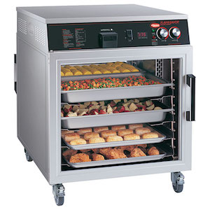
Food Warmer
(C01/3-5-2)
PROCEDURE FOR HANDLING COOKED FO\ODS (HOT HOLDING)

- Always prepare and cook food as desired and not excessive.
- Batch cooking is encouraged to ensure food temperature and food handling are safe.
- Use food warmers, food heating lamps or hot-holding equipment that can handle food at a temperature of 57º Celsius or higher.
- Make sure to follow the manufacturer's instructions when using a food warmer or hot-holding equipment
- For tools that use steam heat, make sure it is filled with hot water and at the desired level.
- Food should be covered to retain heat and prevent contaminants from falling into the food.
- Always check the temperature of food once an hour using a suitable thermometer.
- Record in Holding Temperature Log.
- If the food temperature is below 57º Celsius, the food should be reheated to at least above 74º Celsius.
- Hot food handled for more than four hours below a temperature of 57º Celsius, food must be discarded according to the Four-Hour Rule.
- Do not mix old food with freshly cooked food.
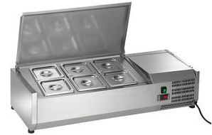
Refrigerated Food Handling
(C01/3-5-2)
PROCEDURE FOR HANDLING COOKED FOODS (COLD HOLDING)

- Use cold food handling tools or refrigerated counters that can keep the food temperature below 5º Celsius.
- Use a thermometer to measure the temperature of food stored / served every hour.
- Record in Holding Temperature Log.
- If the food temperature is served cold at a temperature above 5º Celsius, take immediate action to re-cool the food in the refrigerator or correct the temperature of the equipment.
- Cover food with a food cover to avoid contamination.
- Cold food that is served for more than 4 hours and the temperature of the food is more than 5º Celsius, the food can be discarded according to the Four-Hour Rule.
- Cold / raw food for display should be placed in a container, not placed directly on ice cubes. Except for fruits and vegetables, because those ingredients will be washed before serving.
- Ice for food display must have a water channel to prevent liquid ice from stagnating.

QUESTION:

1. What is the temperature that needs to be followed for the use of a walk-in freezer?

2. What is the proper way to store meat?

